Dot Plots (Strip Charts)

Thurber

## Get Data

Data may be imported from a local file or downloaded from the web. For this example we will use a CSV file downloaded from the web and data entered by hand.

htwt = read.csv("http://bulldog2.redlands.edu/fac/jim_bentley/downloads/math111/htwt.csv")  
 htwt$Group = factor(htwt$Group, labels=c("Male","Female"))  
 head(htwt)

## Height Weight Group  
## 1 64 159 Male  
## 2 63 155 Female  
## 3 67 157 Female  
## 4 60 125 Male  
## 5 52 103 Female  
## 6 58 122 Female

For now, We will focus on the weight (***Weight***) data in the ***htwt*** dataframe.

names(htwt)

## [1] "Height" "Weight" "Group"

htwt$Weight

## [1] 159 155 157 125 103 122 101 82 228 199 195 110 191 151 119 119 112  
## [18] 87 190 87

We can create a quick dotplot/stripchart using the base package.

stripchart(htwt$Weight)

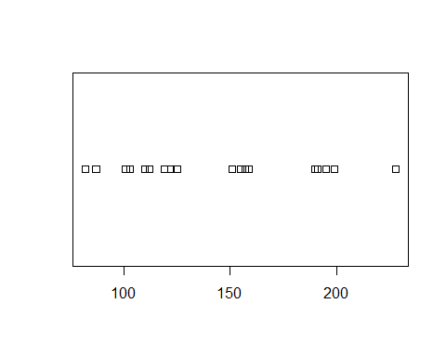

stripchart(htwt$Weight ~ htwt$Group)

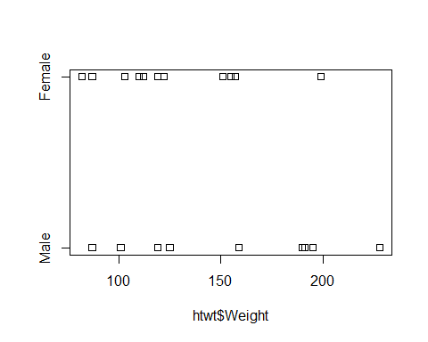

stripchart(Weight ~ Group, data=htwt)

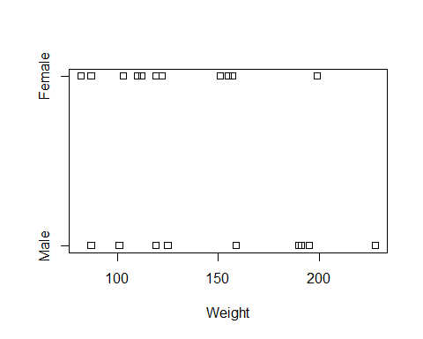

The lattice package provides a little more flexibility in creating dotplots. In particular, considering additional variables through the use of lattices (latti?) is sometimes useful in making comparisons.

# Use the lattice library. cex is the character size multiplier   
 # Using pch=1 chooses open circles which better show overlapped data.   
 p_load(lattice)  
 dotplot(~Weight, data=htwt, cex=1.25, pch=1)

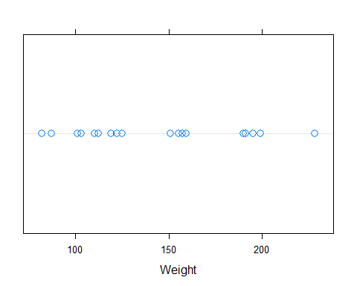

# Lattice requires that the grouping variable be an integer and not factor variable  
 dotplot(as.integer(Group) ~ Weight, data=htwt, cex=1.25, pch=1, ylab="Group")

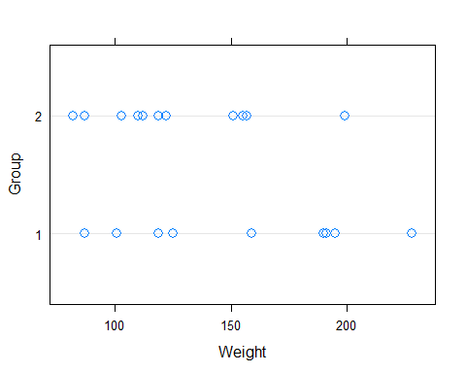

dotplot(~Weight, group=Group, data=htwt, pch=htwt$Group)

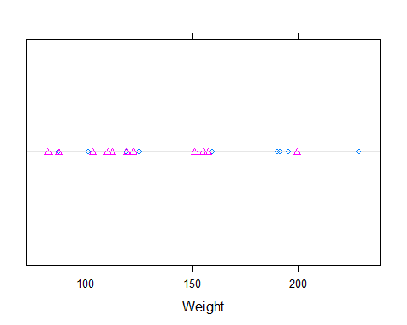

dotplot(~Weight|Group, data=htwt, layout=c(1,2))

