German Tanks
Oliver d’Pug

Simulate a Number of Battles
The function tanks simulates n_reps battles with n_obs serial numbers recorded for each battle. The argument n_tanks is the number of tanks that the Germans had. The argument fixedest is the expert’s best guess.
tanks <- function (n_tanks = 84, n_obs = 5, n_reps = 100, fixedest = 87)
{
temp <- as.matrix(rep(n_tanks, n_reps))
temp <- apply(temp, 1, sample, size = n_obs)
temp <- t(apply(temp, 2, tanks.ests, fixedest))
temp
}

Compute Estimates
The function tank.ests runs on a sample of observed serial numbers. Each of the vector values is the result of a student supplied estimator. These need to be changed to reflect the class’ ideas.
tanks.ests <- function (x = stop("Argument 'x' is missing"), fixedest = 125)
{
n <- length(x)
nodd <- n %% 2 == 1
ests <- rep(NA, 16)
xbar <- mean(x)
xmedian <- median(x)
xn <- max(x)
xvar <- var(x)
xstddev <- sqrt(xvar)
x1 <- min(x)
rng <- c(-1,1)%*%range(x)
xsum <- sum(x)
xnm1 <- sort(x)[n-1]
ests[1] <- 2 * xbar
ests[2] <- 2 * xmedian
ests[3] <- xbar + xmedian
ests[4] <- sum(x[c(n-1,n)])
ests[5] <- nodd * (xmedian + x[(n+1)/2 + 1]) + !nodd * (xmedian + x[n/2 + 1])
ests[6] <- xn + xmedian
ests[7] <- xbar + 2*xstddev
#
y = sort(x)
z = c(NA,y[-n])
ests[8] <- xn + mean(y-z, na.rm = TRUE)
z = c(0,y[-n])
ests[9] <- xn + mean(y-z)
z = c(1,y[-n])
ests[10] <- xn + mean(y-z)
ests[11] <- (3*xn - x1)/2
ests[12] <- (5*xn - xbar)/3
ests[13] <- 3*xmedian + rng
ests[14] <- xn
ests[15] <- xn * ((n+1)/n) - 1
ests[16] <- fixedest
names(ests) <- c("2*xbar", "2*m", "xbar + m", "x[n]+x[n-1]", "m + next biggest",
"x[n] + m", "xbar + 2s", "x[n]+mean(x -lag(x))", "x[n]+mean(x -lag(x) w/ 0)",
"x[n]+mean(x -lag(x) w/ 1)", "(3x[n]-x[1])/2", "(5*x[n]-xbar)/3", "3m + range(x)",
"x[n]", "UMVUE", fixedest)
ests
#ests[1] <- xn
#ests[2] <- 2 * xbar
#ests[3] <- xn + x1
#ests[4] <- xn + rng/2
#ests[5] <- xbar + xstddev
#ests[6] <- 2 * xmedian
#ests[7] <- xn + xnm1
#ests[8] <- 2*xn - x1
#ests[9] <- xsum
#ests[10] <- xn * ((n+1)/n) - 1
#ests[11] <- fixedest
#names(ests) <- c("x[n]","2*xbar", "x[n]+x[1]", "x[n]+R/2", "xbar+s", "2*m",
# "x[n]+x[n-1]","2x[n]-x[1]","sum(x)", "UMVUE",fixedest)
#ests
}

Compute Descriptive Statistics
The function tanks.descriptives computes descriptive statistics for each of the estimators in tanks.ests.
tanks.descriptives <- function (n = 84, obs = 5, reps = 100, fixedest = 87)
{
temp <- tanks(n, obs, reps, fixedest)
means <- apply(temp, 2, mean)
stddevs <- sqrt(apply(temp, 2, var))
medians <- apply(temp, 2, median)
bias <- means - n
mse <- bias^2 + stddevs^2
t(cbind(means, stddevs, medians, bias, mse))
}

Plot Estimates
The individual estimates computed for the samples from each battle can be plotted. This allows us to compare location and dispersion statistics — center and spread. tanks.plots2 is intended to be an “improved” version of tanks.plots. Both plots use traditional lattice boxplots and there is a ggplot plot as well.
### Load the lattice package
p_load(lattice)
tanks.plots <- function (n = 84, obs = 5, reps = 100, fixedest = 87)
{
temp <- tanks(n, obs, reps, fixedest)
tanknames <- attributes(temp)$dimnames[[2]]
dims <- dim(temp)
temp <- as.vector(t(temp))
temp <- cbind(temp, rep(1:dims[2], dims[1]))
bwplot(factor(temp[, 2], labels = tanknames) ~
temp[, 1], xlab = "Number of Tanks",
ylab = "Estimator")
}
tanks.plots2 <- function (n = 84, obs = 5, reps = 100, fixedest = 87)
{
temp <- tanks(n, obs, reps, fixedest)
tanknames <- attributes(temp)$dimnames[[2]]
dims <- dim(temp)
temp <- as.vector(t(temp))
temp <- cbind(temp, rep(1:dims[2], dims[1]))
bwplot(factor(temp[, 2], labels = tanknames) ~
temp[, 1], xlab = "Number of Tanks",
ylab = "Estimator", panel = function (x ,
y , vref = n, ... )
{
panel.bwplot(x, y)
panel.abline(v = vref, lty = 2)
}, vref = n)
}
p_load(ggplot2)
p_load(tidyverse)
tanks.plots3 <- function (n = 84, obs = 5, reps = 100, fixedest = 87)
{
temp <- tanks(n, obs, reps, fixedest)
tanknames <- attributes(temp)$dimnames[[2]]
dims <- dim(temp)
temp <- as.vector(t(temp))
temp <- cbind(temp, rep(1:dims[2], dims[1]))
temp <- as_tibble(temp)
names(temp) <- c("Estimate", "Estimator")
temp$Estimator <- factor(temp$Estimator)
ggplot(temp, aes(x=Estimator, y=Estimate)) +
geom_boxplot(alpha=0.7) +
stat_summary(fun=mean, geom="point", shape=20, size=5, color="red", fill="red") +
theme(legend.position="none") +
scale_fill_brewer(palette="Set1") +
geom_hline(yintercept = n, alpha = 0.5, color = "blue", lty = 1) +
coord_flip()
}
tanks.plots4 <- function (n = 84, obs = 5, reps = 100, fixedest = 87)
{
temp <- tanks(n, obs, reps, fixedest)
temp <- melt(temp)
names(temp) <- c("RowID","Estimator","Estimate")
ggplot(temp, aes(x=Estimator, y=Estimate)) +
geom_boxplot(alpha=0.7) +
stat_summary(fun=mean, geom="point", shape=20, size=5, color="red", fill="red") +
theme(legend.position="none") +
scale_fill_brewer(palette="Set1") +
geom_hline(yintercept = n, alpha = 0.5, color = "blue", lty = 1) +
coord_flip()
}

Compare our Estimators
The class’ estimators can be compared using the functions defined above.
### Compute descriptive stats
tanks.descriptives(n = 47, obs = 5, reps = 10000, fixedest = 50)
2*xbar 2*m xbar + m x[n]+x[n-1] m + next biggest x[n] + m
means 47.88520 47.87300 47.87910 47.65990 47.82310 63.85250
stddevs 11.61528 17.02381 13.89358 18.96896 18.50423 12.77533
medians 48.00000 48.00000 47.80000 48.00000 48.00000 65.00000
bias 0.88520 0.87300 0.87910 0.65990 0.82310 16.85250
mse 135.69839 290.57218 193.80443 360.25688 343.08414 447.21582
xbar + 2s x[n]+mean(x -lag(x)) x[n]+mean(x -lag(x) w/ 0)
means 50.417969 47.898825 47.899200
stddevs 9.190688 7.856860 7.699107
medians 51.438429 49.750000 50.400000
bias 3.417969 0.898825 0.899200
mse 96.151254 62.538142 60.084808
x[n]+mean(x -lag(x) w/ 1) (3x[n]-x[1])/2 (5*x[n]-xbar)/3 3m + range(x)
means 47.699200 55.881650 58.54580 103.74080
stddevs 7.699107 9.506414 9.52518 26.86245
medians 50.200000 57.500000 60.93333 104.00000
bias 0.699200 8.881650 11.54580 56.74080
mse 59.765128 169.255612 224.03454 3941.10936
x[n] UMVUE 50
means 39.916000 46.899200 50
stddevs 6.415922 7.699107 0
medians 42.000000 49.400000 50
bias -7.084000 -0.100800 3
mse 91.347116 59.286408 9
### Plot the estimates from each of the estimators
tanks.plots(n = 47, obs = 5, reps = 10000, fixedest = 50)
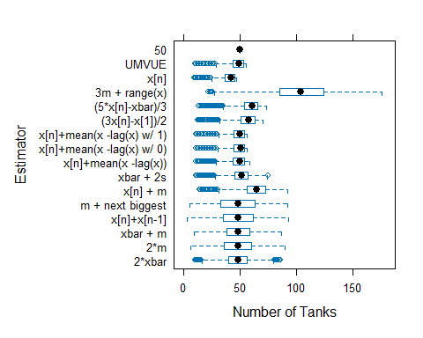
### Plot the estimates from each of the estimators
tanks.plots2(n = 47, obs = 5, reps = 10000, fixedest = 50)
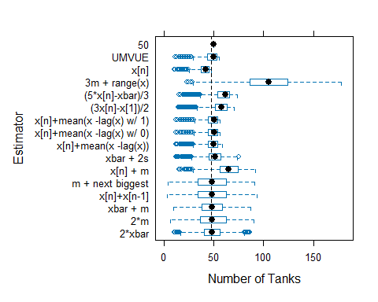
### Plot the estimates from each of the estimators
tanks.plots4(n = 47, obs = 5, reps = 10000, fixedest = 50)
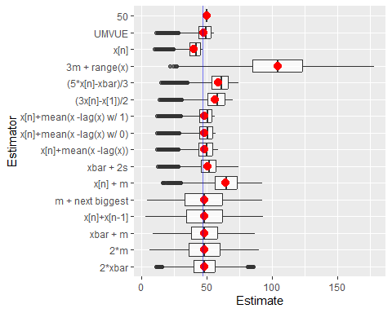
Note that $\hat{N}=X_{\left(n\right)}\frac{n+1}{n}−1$ is UMVUE for $N$ when the $X_{i}$ are i.i.d. DU(1,$N$).

