Bootstrapping

Oliver d’Pug

## Bootstrap “By Hand”

The theoretical distribution of the median is often not very friendly. To get a handle on what the distribution looks like for samples from different population distributions, we can use Efron’s bootstrap.

### The **sample** Function

We will make ample use of the **sample** function. This function returns either a random subset of the original data, or a permutation — depending upon the number of items that you request it returns.

We first create a vector, **x**, that contains integers from 1 to 10.

x = 1:10  
 x

[1] 1 2 3 4 5 6 7 8 9 10

### Or  
 (x = 1:10)

[1] 1 2 3 4 5 6 7 8 9 10

### Or  
 print(x)

[1] 1 2 3 4 5 6 7 8 9 10

Now we sample, with and without replacement, from x. The results need not be stored.

### Get a random sample of size 5 from the n=10 w/o replacement  
 sample(x, 5)

[1] 6 5 3 9 10

### Get a random permutation of the n=10  
 sample(x)

[1] 8 1 7 2 6 3 5 10 4 9

### Get a bootstrap sample (of size n from the n=10 w/ replacement)  
 bootsamp = sample(x, replace = TRUE)  
 bootsamp

[1] 6 2 1 1 2 1 2 8 5 6

The default is to have each item have a selection probability of 1/n. We can specify other probabilities if we so choose.

### Creatae a boostrap sample from x with probabilities that favor the first five elements  
 prob1 = c(rep(.15, 5), rep(.05, 5))  
 rbind(x, prob1)

[,1] [,2] [,3] [,4] [,5] [,6] [,7] [,8] [,9] [,10]  
x 1.00 2.00 3.00 4.00 5.00 6.00 7.00 8.00 9.00 10.00  
prob1 0.15 0.15 0.15 0.15 0.15 0.05 0.05 0.05 0.05 0.05

sample(10, replace = TRUE, prob=prob1)

[1] 3 3 6 1 2 7 4 4 5 3

Sampling from a matrix is done similarly. We can sample from all elements of the matrix.

### Create a matrix filled with random values  
 y1 = matrix( round(rnorm(25,5,2)), ncol=5)  
 y1

[,1] [,2] [,3] [,4] [,5]  
[1,] 5 3 2 3 3  
[2,] 6 2 1 5 10  
[3,] 4 3 4 1 6  
[4,] 2 5 6 4 3  
[5,] 5 6 0 5 6

### Save a sample of size 5 in the vector x1  
 x1 = y1[sample(25, 5)]  
 x1

[1] 2 0 3 3 6

Or, we can sample entire rows.

### Create a matrix filled with random values  
 y2 = matrix( round(rnorm(40, 5)), ncol=5)  
 y2

[,1] [,2] [,3] [,4] [,5]  
[1,] 6 5 5 5 6  
[2,] 6 7 6 5 5  
[3,] 5 5 5 6 5  
[4,] 5 3 4 5 3  
[5,] 6 3 7 4 5  
[6,] 7 5 7 5 5  
[7,] 4 5 4 5 6  
[8,] 7 5 4 5 5

### Save a sample of rows from y2 in the matrix x2  
 n = nrow(y2)  
 (i.rows = sample(n,3))

[1] 3 6 8

x2 = y2[i.rows, ]  
 x2

[,1] [,2] [,3] [,4] [,5]  
[1,] 5 5 5 6 5  
[2,] 7 5 7 5 5  
[3,] 7 5 4 5 5

### More compactly  
 x2 = y2[sample(8, 3), ]  
 x2

[,1] [,2] [,3] [,4] [,5]  
[1,] 7 5 4 5 5  
[2,] 6 7 6 5 5  
[3,] 7 5 7 5 5

### Bootstrapping Using the **sample** Function

In the following example we find an estimate of the standard error for the estimate of the median. We will be using the **lapply** and **sapply** functions in combination with the **sample** function. (More information about the **lapply** and **sapply** functions can be found in the R help pages — **help(“lapply”)** or **?sapply** in the console.)

#### A quick look at **lapply** and **sapply**

Before we go on, let’s take a quick look at matrix computations. R allows us to apply a function to a dimension of a matrix — *i.e.* rows or columns. We apply the **sum** and **mean** functions to a matrix.

### Request the arguments for the matrix function  
 args(matrix)

function (data = NA, nrow = 1, ncol = 1, byrow = FALSE, dimnames = NULL)   
NULL

### Create a matrix of integers  
 x = matrix(1:16, nrow=4, byrow=TRUE)  
 x

[,1] [,2] [,3] [,4]  
[1,] 1 2 3 4  
[2,] 5 6 7 8  
[3,] 9 10 11 12  
[4,] 13 14 15 16

### Find the sum of all elements  
 sum(x)

[1] 136

### Find the row sums  
 args(apply)

function (X, MARGIN, FUN, ..., simplify = TRUE)   
NULL

row.sums = apply(x, 1, sum)  
 cbind(x, row.sums)

row.sums  
[1,] 1 2 3 4 10  
[2,] 5 6 7 8 26  
[3,] 9 10 11 12 42  
[4,] 13 14 15 16 58

### Find the column sums  
 col.sums = apply(x, 2, sum)  
 rbind(x, col.sums)

[,1] [,2] [,3] [,4]  
 1 2 3 4  
 5 6 7 8  
 9 10 11 12  
 13 14 15 16  
col.sums 28 32 36 40

### Total sum reprised  
 sum(x)

[1] 136

sum(row.sums)

[1] 136

sum(col.sums)

[1] 136

### And now for means  
 row.means = apply(x, 1, mean)  
 cbind(x, row.means)

row.means  
[1,] 1 2 3 4 2.5  
[2,] 5 6 7 8 6.5  
[3,] 9 10 11 12 10.5  
[4,] 13 14 15 16 14.5

col.means = apply(x, 2, mean)  
 rbind(x, col.means)

[,1] [,2] [,3] [,4]  
 1 2 3 4  
 5 6 7 8  
 9 10 11 12  
 13 14 15 16  
col.means 7 8 9 10

mean(row.means)

[1] 8.5

mean(col.means)

[1] 8.5

mean(x)

[1] 8.5

Of course, all of the above could have been computed using matrix/vector operations.

dim(x)

[1] 4 4

n = length(x)  
 n.row = n.col = nrow(x)  
   
 (ones = rep(1, n.row))

[1] 1 1 1 1

ones %*% x

[,1] [,2] [,3] [,4]  
[1,] 28 32 36 40

x %*% ones

[,1]  
[1,] 10  
[2,] 26  
[3,] 42  
[4,] 58

ones %*% x %*% ones

[,1]  
[1,] 136

ones %*% x / n.col

[,1] [,2] [,3] [,4]  
[1,] 7 8 9 10

x %*% ones / n.row

[,1]  
[1,] 2.5  
[2,] 6.5  
[3,] 10.5  
[4,] 14.5

ones %*% x %*% ones / n

[,1]  
[1,] 8.5

## Back to the Bootstrap

We return to using the bootstrap to model the sampling distributions of a statistic.

### Create a data set by taking 100 random observations from a normal   
 ### distribution with mean 5 and stdev 3. Each observation has been   
 ### rounded to the nearest integer.  
 data <- round(rnorm(100, 5, 3))  
   
 ### Display the first ten observations  
 data[1:10]

[1] 12 3 10 6 4 1 3 3 7 1

The **lapply** function applies a given function to a list by passing the list elements to the function. We use **lapply** to run a function that generates a sample of the same size as the original sample by sampling with replacement.

### Generate n.boots bootstrap samples. Note that the function has an argument i  
 ### that is not passed to the sample function which uses the global   
 ### data instead.  
 n.boots = 9999  
 resamples = lapply(1:n.boots, function(i) sample(data, replace = T))  
  
 ### Display the results for the third resample --- the others are similar.  
 resamples[3]

[[1]]  
 [1] 0 6 1 6 3 6 3 3 4 10 11 3 6 4 6 5 7 7 10 7 7 7 3 6 7  
 [26] 5 3 5 2 6 5 7 3 10 4 7 7 4 7 1 1 1 5 4 7 7 3 2 4 1  
 [51] 2 -3 1 7 3 2 3 3 7 5 10 4 3 2 3 6 3 10 4 1 9 1 1 12 6  
 [76] 6 4 1 1 3 7 6 10 3 12 4 4 6 5 7 6 1 5 3 5 5 2 7 4 5

We can now apply the **median** function to each of the bootstrap samples to generate a bootstrap distribution.

### Calculate the median for each bootstrap sample   
 r.median <- sapply(resamples, median)  
 r.median[1:15] ### Look at 15 of these

[1] 5.0 4.0 5.0 5.0 4.0 5.0 5.0 4.0 5.0 5.0 4.5 4.5 5.0 5.0 5.0

### Compute summary statistics for the distribution of the medians  
 summary(r.median)

Min. 1st Qu. Median Mean 3rd Qu. Max.   
 3.000 5.000 5.000 4.815 5.000 6.000

### Display a histogram of the distribution of the medians   
 hist(r.median)  
 abline(v=mean(data), lty=3)  
 abline(v=mean(r.median), lty=1)

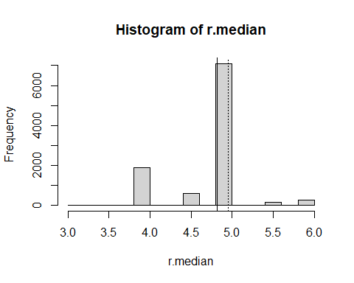

### Display a normal probability plot   
 qqnorm(r.median)  
 qqline(r.median)

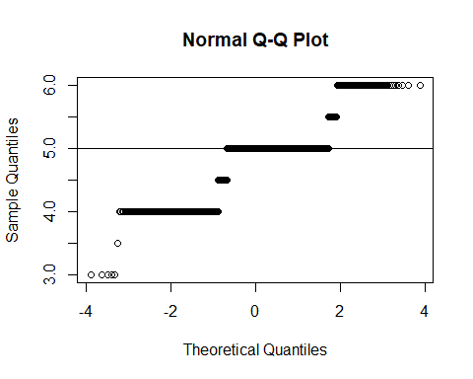

### Display a quantile-quantile plot using a standard normal  
 n = length(r.median)  
 qqplot(qnorm(ppoints(n)), r.median,  
 main = "Q-Q plot for Normal")  
 qqline(r.median, distribution = function(p){qnorm(p)},  
 probs = c(0.25, 0.75), col = 2)

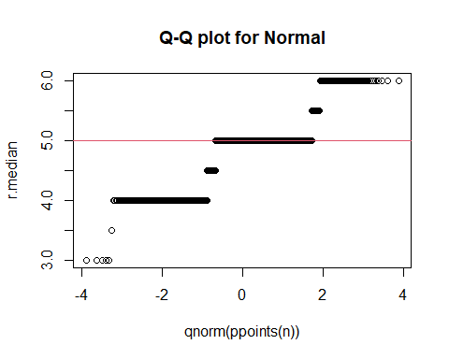

### Display a quantile-quantile plot using a chiquare  
 n = length(r.median)  
 qqplot(qchisq(ppoints(n), df = n-1), r.median,  
 main = expression("Q-Q plot for" ~~ {chi^2}[nu == n-1]))  
 qqline(r.median, qtype = 5, distribution = function(p){qchisq(p, df = n-1)},  
 probs = c(0.1, 0.6), col = 2)  
 mtext("qqline(*, dist = qchisq(., df=n-1), prob = c(0.1, 0.6))")

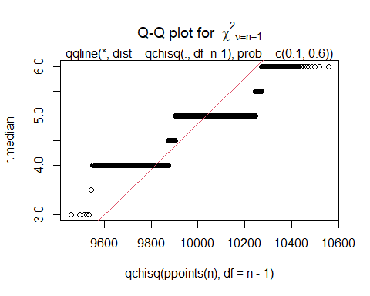

These steps can be combined into a single function where all we would need to specify is which data set to use and how many times we want to resample in order to obtain the adjusted standard error of the median.

### Function to bootstrap the mean, standard error, and bias of the median  
 b.median = function(data, nboot=9999) {  
 resamples = lapply(1:nboot, function(i) sample(data, replace=T))  
 r.median = sapply(resamples, median)  
 d.xbar = mean(data)  
 r.xbar = mean(r.median)  
 r.bias = r.xbar - d.xbar  
 r.stderr = sqrt(var(r.median))  
 list(xbar=r.xbar, std.err=r.stderr, bias=r.bias, resamples=resamples,  
 medians=r.median  
 )   
 }  
  
 ### Create some data to be used (same as in the above example)  
 data1 = round(rnorm(100, 5, 3))  
  
 ### Save the results of 10000 boots of the function b.median in the object b1  
 b1 = b.median(data1, 10000)  
  
 ### Display the third of the 10000 bootstrap samples  
 b1$resamples[3]

[[1]]  
 [1] 7 2 5 6 2 4 5 4 3 6 7 5 1 3 3 3 5 4 5 5 3 5 2 1 3  
 [26] 1 1 7 2 4 2 2 4 4 1 9 4 4 4 9 5 8 4 2 5 9 1 5 3 4  
 [51] 5 7 5 10 5 5 3 5 4 4 13 7 4 0 5 7 4 3 5 3 4 2 6 1 2  
 [76] 5 4 6 4 6 2 5 0 4 1 4 5 2 8 6 8 4 0 5 6 3 5 5 3 5

### Display the mean, standard error, and bias of bootstrapped medians  
 print(c(b1$xbar, b1$std.err, b1$bias))

[1] 4.7920500 0.3912763 -0.1379500

### Display a histogram of the distribution of medians  
 hist(b1$medians)

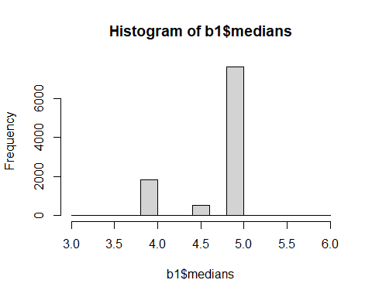

### Make a normal probability plot  
 qqnorm(b1$medians)  
 qqline(b1$medians)

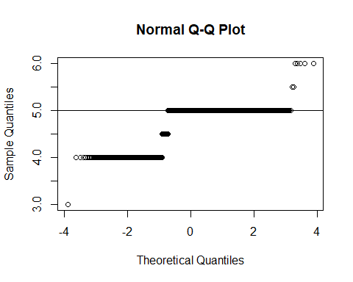

qqPlot(b1$medians)

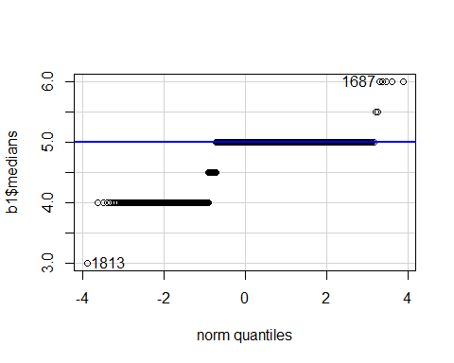

[1] 1813 1687

### We can input the data directly into the function and display   
 ### the standard error in one line of code.  
 b.median(data1)$std.err

[1] 0.38643

### Or, we can make the histogram in one line  
 hist(b.median(data1)$medians)

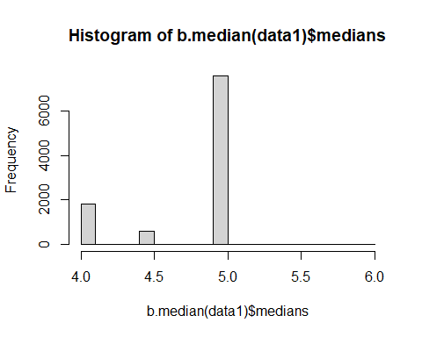

Note that the single line calls generate plots based upon different bootstrap samples. This approach is also not very time efficient.

It would be fairly simple to generalize the function to work for any summary statistic. We show this approach for the sample mean.

### Function to bootstrap the mean, standard error, and bias of a statistic  
 b.stat = function(data, nboot=9999, fnct = mean, ...) {  
 resamples = lapply(1:nboot, function(i) sample(data, replace=T))  
 r.boots = sapply(resamples, fnct, ...)  
 d.xbar = mean(data)  
 r.xbar = mean(r.boots)  
 r.bias = r.xbar - d.xbar  
 r.stderr = sqrt(var(r.boots))  
 list(xbar=r.xbar, std.err=r.stderr, bias=r.bias, resamples=resamples,  
 boots=r.boots  
 )   
 }  
   
 ### Reuse the data created above so that we can compare mean and median  
 ### Save the results of 10000 boots of the function b.median in the object b2  
 b2 = b.stat(data1, 9999, function(x){mean(x)})  
  
 ### Display the third of the 10000 bootstrap samples  
 b2$resamples[3]

[[1]]  
 [1] 4 4 5 5 3 2 6 7 8 7 7 3 2 4 4 8 3 7 5 4 4 5 4 7 7  
 [26] 8 8 6 0 5 7 4 7 3 2 4 2 6 6 5 5 7 8 5 4 8 1 7 8 8  
 [51] 7 4 0 4 5 4 14 4 5 7 4 2 4 8 11 2 8 6 1 4 5 2 11 0 3  
 [76] 7 4 3 4 3 7 1 4 7 2 5 5 2 4 5 6 3 1 5 3 6 2 6 6 5

### Display the mean, standard error, and bias of bootstrapped means  
 print(round(c(b2$xbar, b2$std.err, b2$bias), 4))

[1] 4.9291 0.2777 -0.0009

### Display a histogram of the distribution of means  
 hist(b2$boots)  
 abline(v = b2$xbar, lty = 1)  
 abline(v = mean(data1), lty = 3)

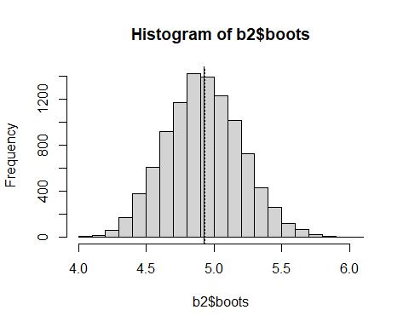

### Make a normal probability plot  
 qqnorm(b2$boots)  
 qqline(b2$boots)

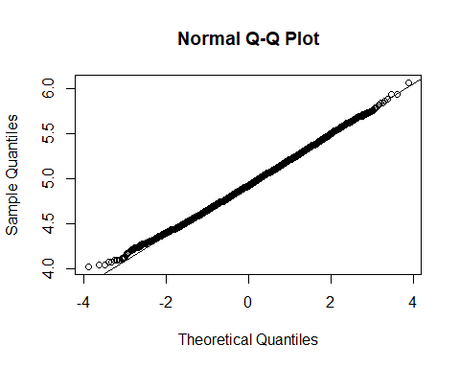

qqPlot(b2$boots)

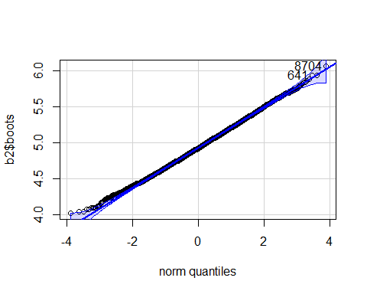

[1] 8704 641

## The **boot** Package

There exists a package, **boot**, that already has a bootstrapping function that acts like the function that we created in the code chunk above. The advantage of using **boot** is that it has some additional methods of doing things.

### Bootstrap of the median of the data1 data from above.   
 ### Make sure that the boot package is installed using  
 ### install.packages("boot"), or use a package like pacman to take care  
 ### of installation and loading.  
 #library(boot)  
 p_load(boot)  
  
 ### Define the median function with data, d, and boot sample indices, i.  
 mystat = function(d, i){  
 median(d[i])  
 }  
   
 ### Use the boot function to run the bootstrap  
 b3 = boot(data1, mystat, R=9999)  
 b3

ORDINARY NONPARAMETRIC BOOTSTRAP  
  
  
Call:  
boot(data = data1, statistic = mystat, R = 9999)  
  
  
Bootstrap Statistics :  
 original bias std. error  
t1* 5 -0.2117712 0.3909131

plot(b3)

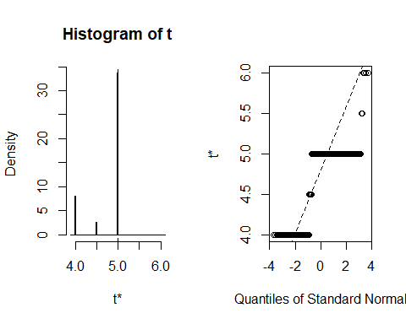

### Display a quantile-quantile plot using a chiquare  
 b3$t[1:15] ### The boot statistics are stored in a variable, t, within the the boot object.

[1] 4.0 5.0 5.0 5.0 5.0 4.5 4.0 4.5 5.0 4.5 5.0 5.0 4.5 5.0 5.0

n = length(b3$t)  
 qqplot(qchisq(ppoints(n), df = n-1), b3$t,  
 main = expression("Q-Q plot for" ~~ {chi^2}[nu == n-1]))  
 qqline(b3$t, qtype = 5, distribution = function(p){qchisq(p, df = n-1)},  
 probs = c(0.1, 0.6), col = 2)  
 mtext("qqline(*, dist = qchisq(., df=n-1), prob = c(0.1, 0.6))")

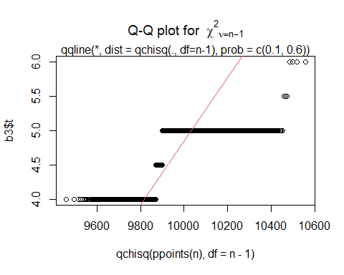

qqPlot(b3$t, distribution="chisq", df=n-1)

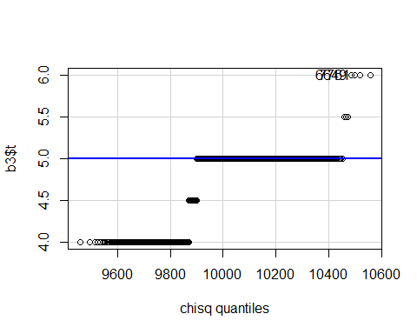

[1] 6649 7761

More complex statistics can be bootstrapped. We look at the mean ratio of weight to height for college students.

### Get the data  
 htwt = read.csv("http://facweb1.redlands.edu/fac/jim_bentley/downloads/math111/htwt.csv")  
 head(htwt)

Height Weight Group  
1 64 159 1  
2 63 155 2  
3 67 157 2  
4 60 125 1  
5 52 103 2  
6 58 122 2

### Usual bootstrap of the ratio of means  
 ratio = function(d, i){ mean(d$Weight[i] / d$Height[i]) }  
 b4 = boot(htwt, ratio, R = 9999)  
 b4

ORDINARY NONPARAMETRIC BOOTSTRAP  
  
  
Call:  
boot(data = htwt, statistic = ratio, R = 9999)  
  
  
Bootstrap Statistics :  
 original bias std. error  
t1* 2.20046 0.0003852534 0.08368918

plot(b4)

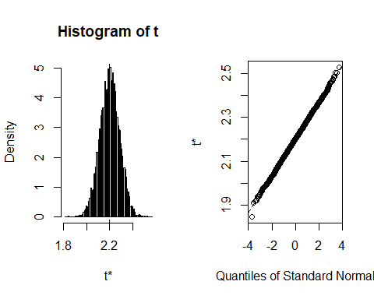

### Display a quantile-quantile plot using a gamma --- which it probably isn't  
 b4$t[1:15] ### The boot statistics are stored in a variable, t, within the the boot object.

[1] 2.076200 2.227477 2.241027 2.222736 2.248693 2.201760 2.277781 2.198977  
 [9] 2.205371 2.265602 2.153788 2.178431 2.208910 2.268837 2.235295

n = length(b4$t)  
 s = var(b4$t)/mean(b4$t) ### Estimate the scale parameter  
 a = mean(b4$t)/s ### Estimate the shape   
 qqplot(qgamma(ppoints(n), shape = a, scale = s), b4$t,  
 main = paste0("Q-Q plot for Gamma(shape = ", round(a,2), ", scale = ", round(s,4), ")")  
 )  
 qqline(b4$t, qtype = 5, distribution = function(p){qgamma(p, shape = a, scale = s)},  
 probs = c(0.1, 0.6), col = 2)

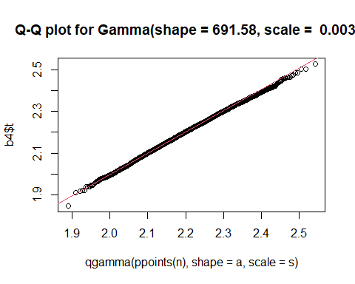

qqPlot(b4$t, distribution="gamma", shape=a, scale=s)

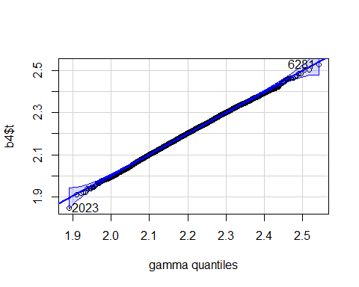

[1] 2023 6281

#### Major parts of this document were taken from UCLA’s stat packages web: <https://stats.idre.ucla.edu/r/faq/how-can-i-generate-bootstrap-statistics-in-r/>

## Generating QQ-Plots

### Using Base R

### Using base R  
 x = rnorm(100,10,5)  
 qqnorm(x)  
 qqline(x)

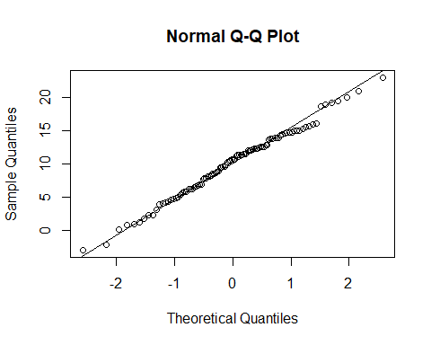

### Using the **car** package

p_load(car)  
  
 qqPlot(x=rnorm(100,10,5))

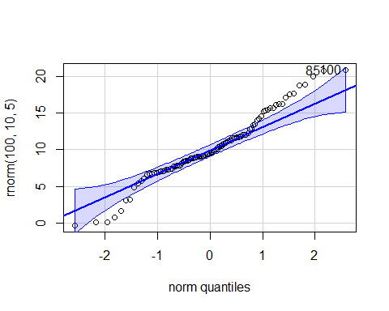

[1] 100 85

qqPlot(x=rnorm(100,10,5), distribution="chisq", df=5)

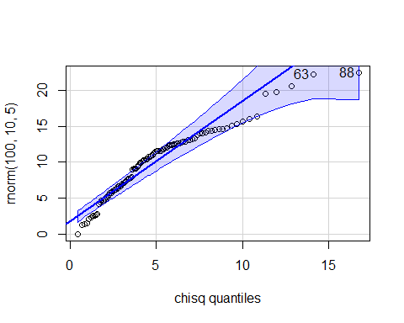

[1] 88 63

qqPlot(x=rchisq(100,5), distribution="chisq", df=25)

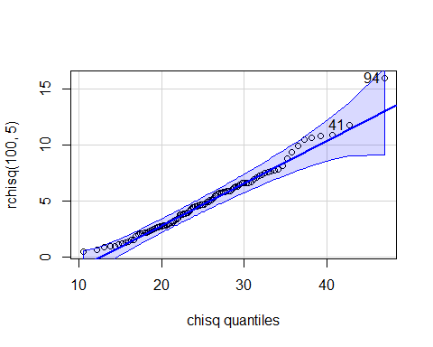

[1] 94 41

qqPlot(x=rchisq(100,5), distribution="chisq", df=5)

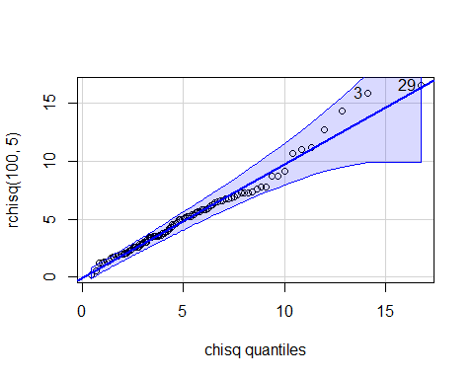

[1] 29 3

### Using **ggplot2**

p_load(ggplot2)  
 p_load(qqplotr)  
 p_load(dplyr) ### Needed for piping and tibble creation   
  
 tibble(x = rnorm(100,10,5)) %>%  
 ggplot(aes(sample = x)) +  
 stat_qq_band(bandType = "pointwise", fill = "#8DA0CB", alpha = 0.4) +  
 stat_qq_line(colour = "#8DA0CB") +  
 stat_qq_point() +  
 ggtitle("Normal") +  
 xlab("Normal quantiles") +  
 ylab("rnorm(100,10,5") +  
 theme_light()

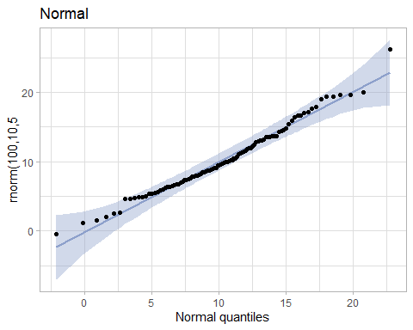

tibble(x = rchisq(100,5)) %>%  
 ggplot(aes(sample = x)) +  
 stat_qq_band(bandType = "pointwise", fill = "#8DA0CB", alpha = 0.4) +  
 stat_qq_line(colour = "#8DA0CB") +  
 stat_qq_point(distribution="chisq") +  
 ggtitle("Chisquare") +  
 xlab("Chisq quantiles") +  
 ylab("rchisq(100,5") +  
 theme_light()

