Name ________________________________ Section ______________________

Answer all questions in pen.
Calculators are allowed.

- (10 pts) Indicate True (T) or False (F). If we can’t tell which it is, you get no credit.

  - ____F____ The Sun is a fairly normal F2 type star.
  - ____F____ The method of trigonometric parallax can be used to yield precise distance to stars in the center of the Milky Way.
  - ____F____ The convection layer in the Sun is transparent to radiation.
  - ____F____ Nuclear fusion is the breaking apart of a heavy atomic nucleus into two smaller nuclei.
  - ____T____ No light produced in the core of the Sun ever reaches the surface.
  - ____T____ Near the event horizon of a black hole, time runs slower than it does farther away from the black hole.
  - ____F____ M stars go through their nuclear hydrogen fuel faster than A type stars.
  - ____T____ It is very cold in the center of a dust cloud.
  - ____F____ Globular clusters orbit the galaxy in a plane while open clusters are found in a spherical halo centered on the Galactic Center.
  - ____T____ Dust grains reflect or scatter light with a wavelength that is smaller than it.

- (15) Millions, Billions or One. This is an “order of magnitude” question. Pick the number (the order of magnitude) that is closest for each.

  - _millions_The temperature in the core of the Sun.
  - ___one__ The size of a typical black hole’s event horizon (in kilometers) created in the death of a star 10 times the mass of the Sun.
  - _billion_ The number of stars in the Milky Way.
  - _millions_ The lifetime of an O or B type star on the main sequence.
  - _millions_ The length of time a star like the Sun spends as a Red Giant.
  - __one_ The length of a day (in seconds) on the surface of a pulsar.
  - __millions__ The distance (in parsecs) to the Andromeda Galaxy.
  - ___one_ The distance (in megaparsecs) to the Andromeda Galaxy.
  - _millions__ The distance (in light years) to the Andromeda Galaxy.
  - __one__ The average distance (in parsecs) between stars.
  - __billions_ The age of the Sun.
  - __one__ Temperature inside an interstellar dust cloud.
  - __one___ Number of times the Sun has orbited the Galactic Center.
  - __one___ Number of stars in the Solar System.
  - _millions__ How long a star like the Sun spends as a protostar.

- (2) In a Main Sequence star, where does all the nuclear fusion take place?

________core________

- (2) Is a Red Giant hotter or cooler than when it was on the Main Sequence?

_______cooler_________

- (2) If a stellar remnant is smaller than 1.4 times the mass of the Sun it is called what?

________white (or black ) dwarf________

- (2) A pulsar is a rapidly spinning what?_________neutron star________

- (2) What is the distance from a black hole inside of which no light can ever escape?

_______event horizon__________

- (2) What type of galaxy is nothing but old stars, it has no gas or new stars being born?

_________elliptical________

- (2) In an H-R diagram, what is the basic property of a star that determines where it is located on the main sequence?

________mass_________

- (2) What is the roman numeral symbolizing the luminosity class for main sequence stars._V_

- (4) What are the seven letters used for spectral classifications of stars? Order them from hottest to coolest.
_________________O B A F G K M____________________

- (4) What is the law of conservation of mass and energy? How is it relevant to nuclear fusion in the Sun?

The sum of mass and energy must always remain constant. The mass of 4 hydrogen atoms is more than 1 helium atom. The missing mass becomes energy.

- (5) What is a standard candle? How is it used to find distances? Give an example.

A standard candle is any class of objects with a known luminosity or absolute magnitude. If we know an apparent magnitude and its luminosity or absolute magnitude, we can determine its distance.

- (5) How is a reflection nebula different from an emission nebula? In general, what color is each?

A reflection nebula is made of dust and thus reflects blue light (looks blue). Emission nebula are made of gas and emit the red light of hydrogen (looks red).

- (8) What are the two main postulates of General Relativity? What are two results regarding the environment around a black hole which result from these? Be brief (4 sentences will suffice).

Speed of light is a constant.
Accelerations are indistinguishable from being in a gravitational field.

Results:
Gravity bends light.
Time slows down near an Event Horizon.

- (7) Describe the steps used in getting a distance to a star using spectroscopic parallax. What pieces of information do you need to know in order to use this method? Be specific.

Observe apparent magnitude (how bright does it looks from Earth).
Use spectral type and luminosity class to find position on H-R diagram.
Use H-R diagram to get absolute magnitude.
With apparent and absolute magnitudes get distance with m-M=5 log (d/10)

- (4) What evidence is there for Dark Matter in the galaxy? Be brief.

Stars near the edge of the galaxy rotate around the galaxy faster than what Kepler’s Laws would predict.

- (4) Describe two techniques for measuring the mass of a galaxy.

Apply Kepler’s laws to:
            - stars around a galaxy
            - binary galaxies (2 galaxies orbiting each other)

- (6) What is Hubble’s Law? Draw a diagram to help illustrate. Label your axes.

Velocity of a galaxy is proportional to its distance (+3)

V

D

1point each for the line and each axis labeled correctly.

- (14) Draw an H-R diagram. Label the axes (2) and the direction the axes increase (2). Include:
  - Main Sequence (2)
  - Red Giant Branch (2)
  - Red Supergiant Branch (1)
  - Blue Giants (1)
  - White Dwarfs. (1)
  - Label the position of the Sun. (1)
  - Draw the evolutionary path the Sun will take once it leaves the Main Sequence. (2)

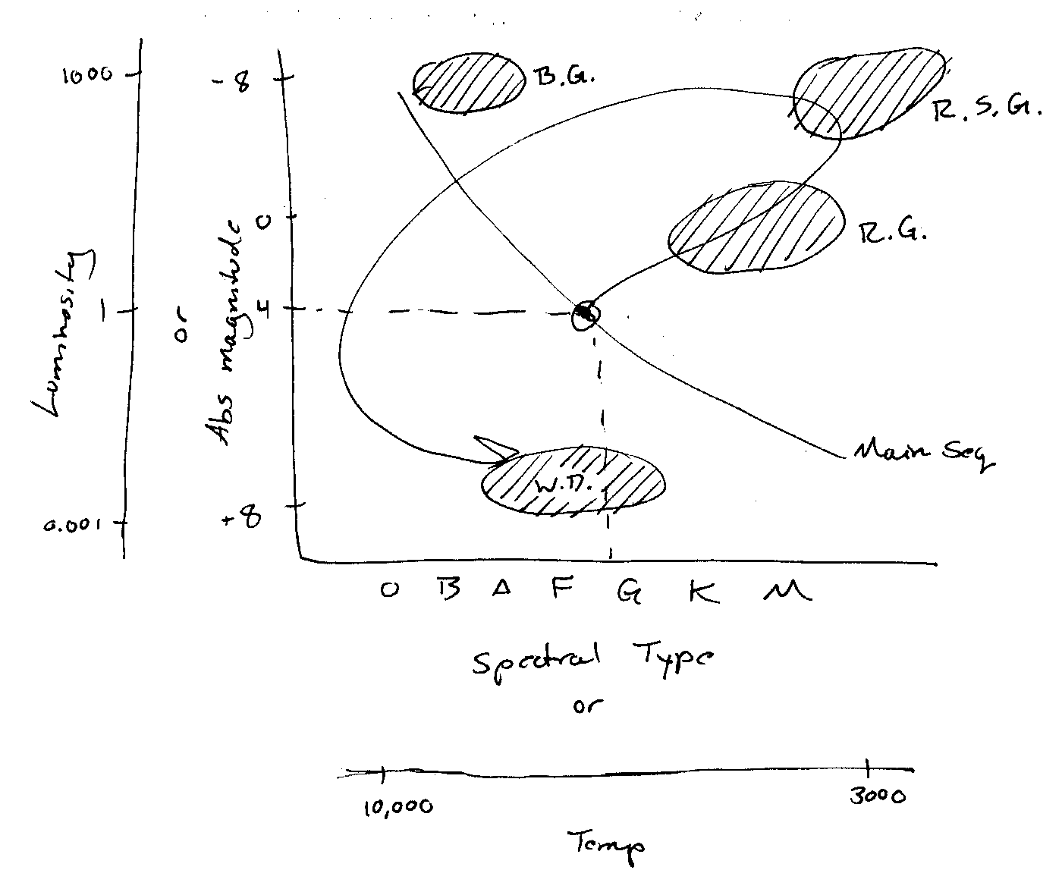

- (5) Calculate the total mass of the Galaxy lying within 20 kpc of the Galactic center if the rotation speed at that radius is 240 km/s. 1 pc = 3 x 10¹⁸ cm. Show all work.
$$\text{Total Mass }(\text{solar masses})=\frac{\text{orbit size }(\text{AU})^{3}}{\text{orbit period}(\text{yrs})^{2}}$$

$$\begin{aligned}r=\text{20}\text{ kpc} \\ =\text{20000}\text{ pc} \\ =4\text{.}\text{125}×{\text{10}}^{9}\text{ AU}\end{aligned}$$

$\begin{aligned}P=\frac{\text{dist}}{\text{vel}} \\ =\frac{2πr}{v} \\ =\frac{2π×\text{20,000 pc }×\text{ 3}×{\text{10}}^{\text{12}}\text{ km}}{\text{240}\text{ km/s}} \\ 1\text{.}\text{57}×{\text{10}}^{\text{16}}\text{ sec} \\ 4\text{.}\text{98}×{\text{10}}^{8}\text{ years}\end{aligned}$ $\begin{aligned}M=\frac{(4\text{.}\text{125}×{\text{10}}^{9}\text{ AU})^{3}}{(2\text{.}8×{\text{10}}^{8}\text{ years})^{2}} \\ 2\text{.}8×{\text{10}}^{\text{11}}\text{ solar masses}\end{aligned}$

- (5) Given that the solar spectrum corresponds to a temperature of 5800 K and peaks at a wavelength of 500 nm, use Wien’s law to determine the wavelength corresponding to the peak of the black-body curve on the surface of Betelgeuse, where the temperature is 3100 K. Show all work.

$$\text{Peak wavelength}∝\frac{1}{\text{Temperature }(K)}$$

$\begin{aligned}\text{Peak wavelength}=\frac{k}{\text{Temperature }(K)} \\ \text{500}\text{ nm}=\frac{k}{\text{5800 K}}\end{aligned}$ $k=\text{500}\text{ nm}×\text{5800}\text{ K }=2,\text{900},\text{000}\text{ nmK}$

$$\begin{aligned}λ=\frac{2,\text{900},\text{000}\text{ nmK}}{T} \\ =\frac{2,\text{900},\text{000}\text{ nmK}}{\text{3100}\text{ K}} \\ =\text{935}\text{ nm}\end{aligned}$$
23. (8) Give the Hubble classification for the two galaxies shown below. Briefly describe the characteristics that made you classify them the way you did.

  - Galaxy a: SBC (1) spiral arms (1) wide arms (1) Bar (1)
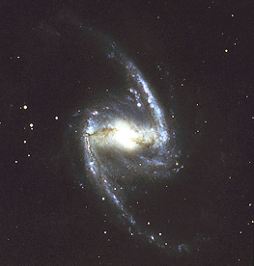

  - Galaxy b: Sb or Sa (1) spiral arms (2) tight arms (1)
