Name ________________________________ Section ______________________

Answer all questions in pen.
Calculators are allowed.

- (10 pts) Indicate True (T) or False (F). If we can’t tell which it is, you get no credit.

  - ____T____ All pulsars are rapidly spinning neutron stars.
  - ____F____ Globular clusters orbit the galaxy in a plane while open clusters are found in a spherical halo centered on the Galactic Center.
  - ____F____ Emission nebulae are blue.
  - ____T____ It is very cold in the center of a dust cloud.
  - ____T____ Near the event horizon of a black hole, time runs slower than it does farther away from the black hole.
  - ____T____ No light produced in the core of the Sun ever reaches the surface.
  - ____T____ Our Sun is a fairly normal G2 type star.
  - ____F____ The convection layer in the Sun is transparent to radiation.
  - ____F____ The method of trigonometric parallax can be used to yield precise distances to nearby galaxies.
  - ____F____ The spectral type for Giants is the roman numeral: V

- (13) Millions, Billions or One. This is an “order of magnitude” question. Pick the number (the order of magnitude) that is closest for each.

  - ___one_____ Average distance (in parsecs) between stars.
  - ____billions____ Current age of the Sun in years.
  - ___millions_____ Length of time a star like the Sun spends as a Red Giant.
  - ___billions_____ Number of stars in the Milky Way.
  - ___one_____ Number of stars in the Solar System.
  - ___millions_____ Temperature in the Sun’s core.
  - ___one_____ Temperature at the Sun’s surface.
  - ___millions_____ Temperature at the Sun’s core.
  - ___millions_____ The distance (in light years) to the Andromeda Galaxy.
  - ___one_____ The distance (in megaparsecs) to the Andromeda Galaxy.
  - ___millions_____ The distance (in parsecs) to the Andromeda Galaxy.
  - ___one_____ The length of a day (in seconds) on the surface of a pulsar.
  - ___millions_____ The lifetime of an O or B type star on the main sequence.

- (2) Which type of star goes through its hydrogen fuel faster, an A0 or an M6?

_______A0_________

- (2) Is a Red Giant star bigger or smaller than when it was on the main sequence?

________bigger_______

- (2) A stellar remnant solely supported from collapse by electron degeneracy pressure is a

______white dwarf__________

- (2) Two atoms combining to form a third and producing energy is called nuclear fusion or fission?

________fusions_________.

- (2) What is the name of the radius of a black hole inside of which no light can ever escape?

______event horizon___________

- (4) Name two things a spiral galaxy has that an elliptical galaxy doesn’t (besides spiral arms)?

Any two of: dust, gas, young stars, star formation

- (2) What is the basic property of a star that determines how it will die?

________mass_________

- (2) Dust grains reflect more red or blue light?__________blue______________

- (4) What are the seven letters used for spectral classifications of stars? Order them from coolest to hottest.
__________M K G F A B O___________________________

- (4) What is the law of conservation of mass and energy? How is it relevant to nuclear fusion in the Sun?

The sum of mass and energy must always remain constant. The mass of 4 hydrogen atoms is more than 1 helium atom. The missing mass becomes energy.

- (6) How do you use a variable star to find its distance (pick either a Cepheid or an RR Lyra variable)?

RR Lyra – They are 100x the luminosity of the Sun.
Cephids – Their luminosity is proportional to their period.
Since you can always tell how bright a star looks from the earth, once you know the luminosity you can determine the distance using: m-M=5 log (d/10)

- (5) What color is a reflection nebula (such as the Witch-head Nebula) and why?

Blue. Dust reflects blue light from another star toward us.

- (8) What are the two main postulates of General Relativity? What are two results regarding the environment around a black hole which result from these? Be brief (4 sentences will suffice).

Speed of light is a constant.
Accelerations are indistinguishable from being in a gravitational field.

Results:
Gravity bends light.
Time slows down near an Event Horizon.

- (8) What information do you need in order to find a star’s distance using the method of spectroscopic parallax? Be specific.

Observe apparent magnitude (how bright does it looks from Earth).
Use spectral type and luminosity class to find position on H-R diagram.
Use H-R diagram to get absolute magnitude.
With apparent and absolute magnitudes get distance with m-M=5 log (d/10)

- (4) What evidence is there for Dark Matter in the galaxy? Be brief.

Stars near the edge of the galaxy rotate around the galaxy faster than what Kepler’s Laws would predict.

- (8) Draw the Hubble Tuning-fork Diagram. Label the different classifications.

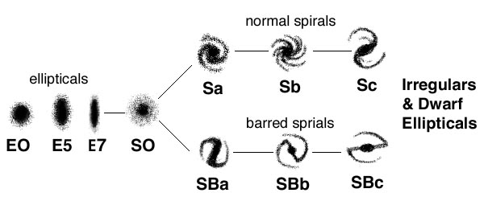

- (14) Draw an H-R diagram. Label the axes and the direction the axes increase. Include:
  - Main Sequence
  - Red Giant Branch
  - Red Supergiant Branch
  - Blue Giants
  - White Dwarfs.
  - Label the position of the Sun.
  - Draw the evolutionary path an evolving protostar takes to get on the main sequence.

NOTE: The evolutionary track shown is for the Sun moving off the main sequence.
The correct answer for this question is on page 291 of the text.
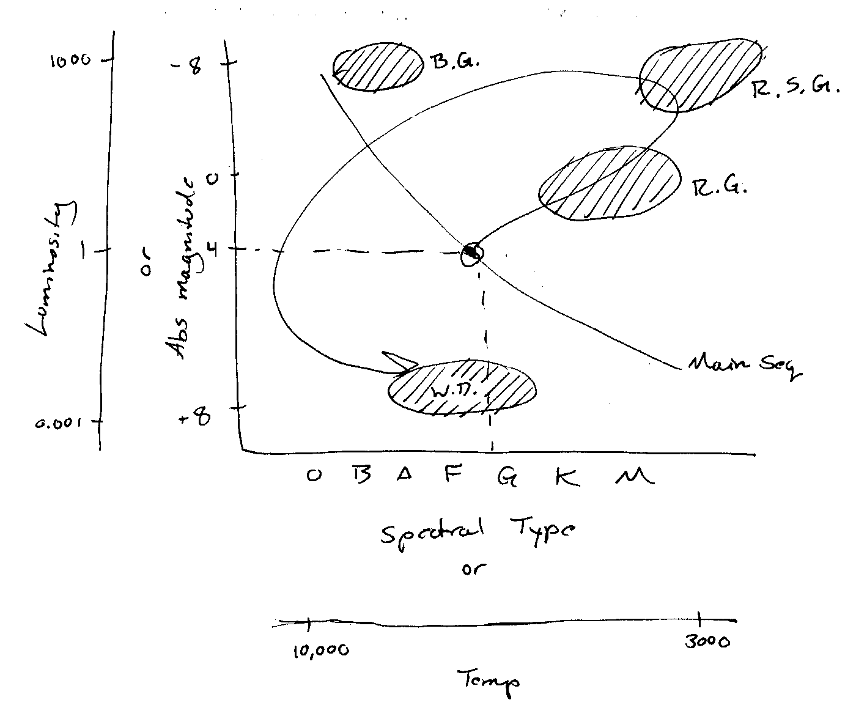

- (5) Two galaxies orbit one another at a separation of 500 kpc. Their orbital period is estimated to be 30 billion years. Use Kepler’s third law to find the total mass of the pair. Show all work. Possibly helpful values and equations: 1 pc = 3 x 10¹⁸ cm, 1 pc = 206,265 AU, 1 year = 30 million seconds.
$$\text{Total Mass }(\text{solar masses})=\frac{\text{orbital separation }(\text{AU})^{3}}{\text{orbit period}(\text{yrs})^{2}}$$

$$\text{Orbital separation }(\text{AU})=\text{ 500 kpc }×\text{1000 }\frac{\text{pc}}{\text{kpc}}×\text{206265}\frac{\text{AU}}{\text{pc}}=1\text{.}\text{03}×{\text{10}}^{\text{11}}\text{AU}$$

$$\text{Total Mass }(\text{solar masses})=\frac{(1\text{.}\text{03}×{\text{10}}^{\text{11}}\text{ AU})^{3}}{(\text{30}\text{.}0×{\text{10}}^{9}\text{ years})^{2}}=\frac{1\text{.}\text{09}×{\text{10}}^{\text{33}}}{9×{\text{10}}^{\text{20}}}=1\text{.}\text{21}×{\text{10}}^{\text{12}}\text{ solar masses}$$

- (5) Given that the solar spectrum corresponds to a temperature of 5800 K and peaks at a wavelength of 500 nm, use Wien’s law to determine the temperature of Betelgeuse whose black-body curve peaks at 900 nm. Show all work.

$$\text{Peak wavelength}∝\frac{1}{\text{Temperature }(K)}$$

$$\text{900}\text{ nm }=\frac{k}{T}\text{ 500 nm }=\frac{k}{\text{5800 K}}$$

$$\begin{aligned}\text{900}\text{ nm }×\text{ T }=k=\text{500}\text{nm }×\text{ 5800 K} \\ T=\frac{\text{500nm }×\text{ 5800 K}}{\text{900}\text{nm}}=\text{3222}\text{ K}\end{aligned}$$
(8) Give the Hubble classification for the two galaxies shown below. Briefly describe the characteristics that made you classify them the way you did.

  - Galaxy a: E0 or E1 (1) elliptical (2) almost circular (1)
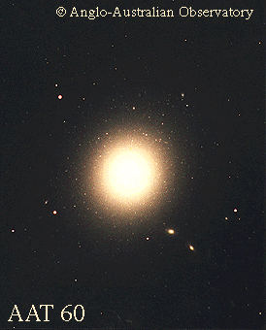

  - Galaxy b: Sb (1) Spiral (2) moderately wound (1)
