Name ________________________________ Section ______________________

Answer all questions in pen.
Calculators are allowed.

- (20 pts) Indicate True (T) or False (F). If we can’t tell which it is, you get no credit.

  - ___F____The star Polaris (also called the North Star) rises in the East and sets in the West as viewed from Redlands.
  - ___T____There are constellations one can see at night in Fall, but not see in Spring.
  - ___F____The seasons on Earth are caused by the changing distance between the Earth and Sun.
  - ___F____Since the moon is 30 arcminutes in angular diameter, that means it must be 1/2 an arcsecond in angular diameter.
  - ___F____Radio waves travel at the speed of sound.
  - ___T____The wavelengths of the emission lines produced by an element are the same as the wavelengths of the absorption lines produced by the same element.
  - ___T____ Terrestrial planets have higher densities than Jovian planets.
  - ___F____ The closer a planet is to the Sun the longer it takes to orbit the Sun.
  - ___T____ Tectonism is an endogenic surface process.
  - ___F____ Only two of the Jovian planets have rings.

- (2) Name the constellation Mars just passed through. ___Sagittarius (teapot also accepted)__

- (3) You learn that there is going to be a total lunar eclipse tonight from Redlands right after sunset. Circle your answers.
  - In what direction do you look for the eclipsed moon? iii
    - North
    - South
    - East
    - West
  - At this time, will the moon be closer to the: ii
    - Zenith or
    - Horizon
  - Will this event be visible to: i
    - nearly everyone in this hemisphere or
    - just those people within a narrow band passing through Redlands

- (2) Vega and Altair are two of the stars that make up the Summer Triangle. What is the third?

______Deneb__________________

- (2) In the greenhouse effect, sunlight is absorbed by the earth’s surface and is reemitted in what part of the electromagnetic spectrum?

___________Infrared___________________

- (2) When the planets Mars, Jupiter, and Saturn appear to move “backwards” (westward) in the sky relative to the stars, this is known as ____retrograde_________ motion.

- (3) The Moon lies 384,000 km from Earth and the Sun lies 150,000,000 km away. If both have the same angular size, how many times larger than the Moon is the Sun?

$$\begin{aligned}\text{tan}θ=\frac{d}{D} \\ \frac{d_{\text{moon}}}{D_{\text{moon}}}=\text{tan}θ=\frac{d_{\text{sun}}}{D_{\text{sun}}} \\ \frac{d_{\text{moon}}}{D_{\text{moon}}}=\frac{d_{\text{sun}}}{D_{\text{sun}}} \\ \frac{D_{\text{sun}}}{D_{\text{moon}}}=\frac{d_{\text{sun}}}{d_{\text{moon}}}=\frac{\text{150},\text{000},\text{000}\text{ km}}{\text{384},\text{000}\text{ km}}=\text{391}\text{ x larger}\end{aligned}$$

- (10) Consider the binary star Albireo which we observed on several occasions.

    - What colors are the two stars in Albireo? _____blue___ and __yellow__

    - Which one is brighter (name its color)? _______yellow_______

    - Which one is hotter (name its color)? __blue___________

    - Why is the hotter one not the brightest?

The yellow star is bigger. So, while the blue star radiates more light per area, the yellow star has much more area.

- (4) Name the two planets in the solar system that don’t have moons.

_________Mercury___________ and _________Venus___________

- (2) Besides the tail, name one difference between the composition of comets and asteroids.

Comets are icy while asteroids are rocky.

- (2) What is the major component of the Earth’s atmosphere? _________Nitrogen______

- (2) How many men have walked on the Moon? _______12_________

- (2) What is the smallest planet in the solar system? _______Pluto_________

- (2) Which planet has the lowest density? _____Saturn___________

- (2) Which planet has the most large moons? _______Jupiter________________

- (8) A. Which solar system bodies have active volcanism?

Earth, Io
B. Pick one of these bodies and explain where the energy for driving the volcanism comes from. Be sure to indicate which body you choose.

Io – tidal heating
-or-
Earth – radioactivity, internal heat
(6) The following figure shows the path of an orbiting planet as viewed from directly above.

S X F

A. Place an “X” at the approximate location of the Sun.

B. Place an “F” at the place in its orbit where the planet moves the fastest.

C. Place an “S” at the place in its orbit where the planet moves the slowest.

- (3) Why do only exogenic processes occur on asteroids?

Asteroids are small bodies with little internal heat. Not enough for endogenic activity.

- (3) The Moon has no aurorae. What does this tell you about navigation with a compass?

With no aurorae there must be no magnetic field so a compass will not work.

- (4) In Michael Crichton’s book “Jurassic Park” on page 72 the mathematician is described as dressed entirely in black. When asked if he finds it’s a little hot to be dressed in black he replies: “As a matter of fact, black is an excellent color for heat. If you remember your black-body radiation, black is actually best in heat. Efficient radiation.” Briefly describe why the mathematician, and by extension Michael Crichton, don’t know what they’re talking about and why it would really be best to dress all in white in the hot sun.

A blackbody absorbs all energy that falls on it, thus warming up. A white object reflects most of the energy, thus it doesn’t warm up as much.

- (10) For each of the following images: describe the feature; determine by what process it was formed and whether the process is exogenic or endogenic. Mention any clues in the image that tell you what planetary body the image is on and name that body if you can.

A.
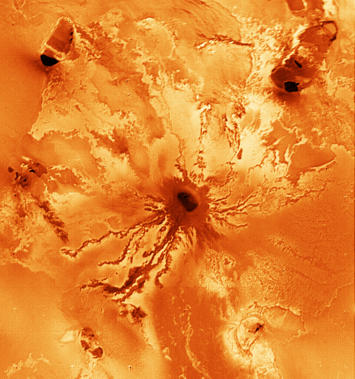 Sinuous trails (wiggly lines) emanating from a single point indicate volcanism, an endogenic process. While there are few visible clues, one might be the lack of impact craters (young surface). This happens to be Io.

B.
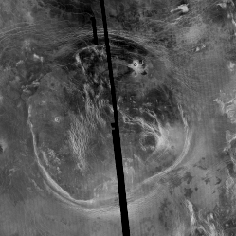 This is a circular feature of with well-defined margins. It is tectonic (corona) which is an endogenic process. Coronae only occur on Venus.
22. (2) What does a reflecting telescope have that a refractor doesn’t have? _________mirror_____

- (4) The reflector on Mount Wilson is 100 inches in diameter. The Meade reflector we looked through in Angelus Oaks is 10 inches in diameter.
  - Which telescope is more sensitive (i.e., collects more light)?

Mt. Wilson
  - How many times more sensitive is it?

$$(\frac{\text{100}\text{ inches}}{\text{10}\text{ inches}})^{2}={\text{10}}^{2}=\text{100}\text{ times more sensitive}$$

- (2) The two images below show the same star field photographed through a red filter and then a blue filter. Three stars are labeled. Please order them from hottest to coolest.
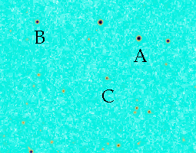
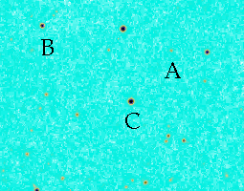

BLUE RED

Hottest ____A_______ _________B____ _______C_____ Coolest

- (4) You observe a cloud of gas in space. By passing the light from this cloud through a slit and a prism you detect bright emission lines in its spectrum. Name two things you can learn about the cloud by observing its spectrum.

Any two of the following:
Composition
Velocity toward or away
Rotation
Magnetic field
pressure
- (4) What do I mean when I say that the solar system is differentiated?

The composition of planets changes with distance from the sun. Planets near the sun are made of stuff with high density and high melting temperature. Density and melting temperature decrease with distance from the sun.

- (4) What configuration of the Earth, Sun, and Moon gives rise to Spring Tides (highest high tides)? Draw a picture if that would help.

The Sun, Moon and Earth lie along the same line:

Sun moon earth

- (6) Give three arguments people give for demoting Pluto from planetary status.

Any three of the following:
Pluto is small, smaller than many moons.
Pluto doesn’t fit into either terrestrial or jovian planet categories
It has a large moon relative to its size which makes it more like a double planet
It is in an odd orbit (high inclination and eccentricity)
It’s composition is similar to some outer solar system satellites
It’s orbit is similar to Kuiper Belt Objects

