Group Name ________________________________ Section ______________________

Lab Partners: Date _____________________

PHYSICS 103
FALL 2001
Laboratory Exercise #6 – Part I

GALAXY CLASSIFICATION

Purpose: To develop a system by which to classify galaxies. To experience why classification is an important first step to understanding. To experience the difficulty with any classification scheme.

INTRODUCTION

When faced with a new kind of object, the first thing scientists usually do is describe what it looks like. Then they identify features that appear the same as or different from other members of the new class. Finally, they try to understand what causes these similarities and differences.

This activity encourages you to look at photographs of galaxies and to discover similarities and differences in the way they look. You will then sort the galaxies into different categories, based on what you see. Astronomer Edwin Hubble did essentially the same thing in the 1920s, when he devised a system for classifying galaxies by shape that proved extremely useful in helping us understand galaxies. His system is still widely in use, although it is being modified by new discoveries that indicate that galaxy shape depends greatly on the environment in which a galaxy is born.

PART 1: DEVISE A CLASSIFICATION

Instructions

On the following pages you will find images of 32 different galaxies. You will devise a scheme by which to classify the galaxies. First, look at all the galaxies. Ask yourself and your lab partners: What types of features do these galaxies possess? What are some similarities and differences between the different galaxies? Try to put the galaxies into classes or categories. YOU MAY SEPARATE THE IMAGES IF IT WILL HELP. Once you have placed the galaxies into categories, come up with names and descriptions of each category.

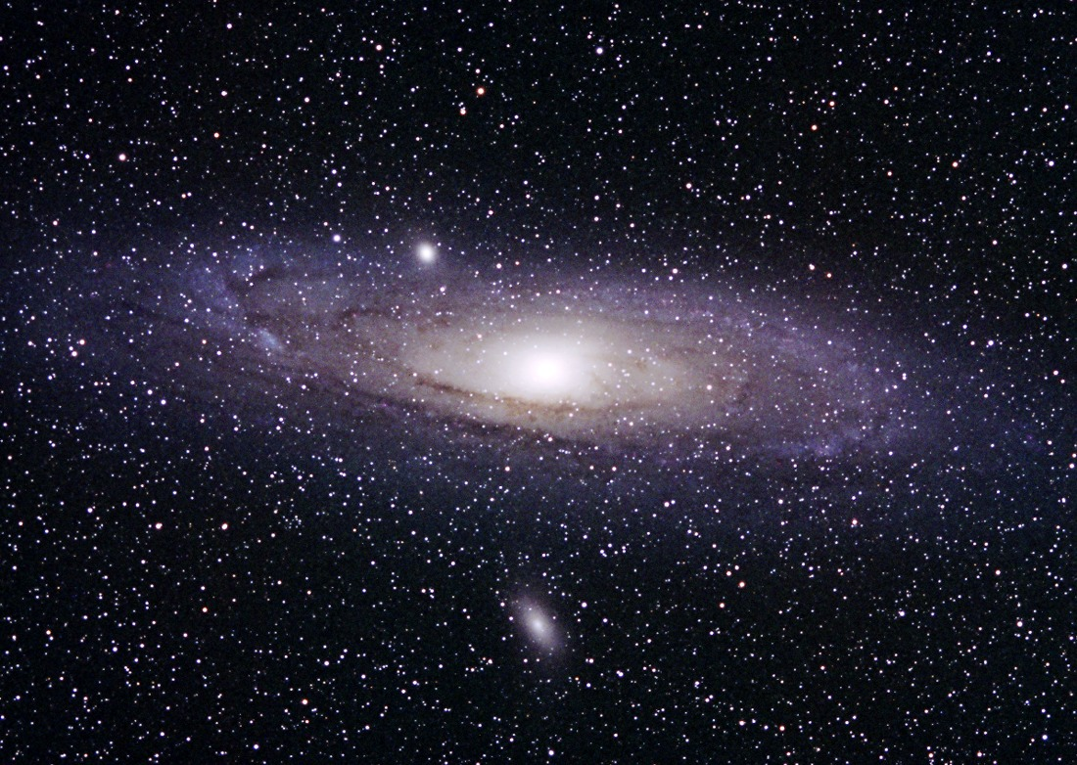  1) M31 | 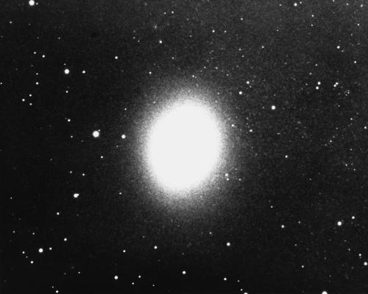  2) M32
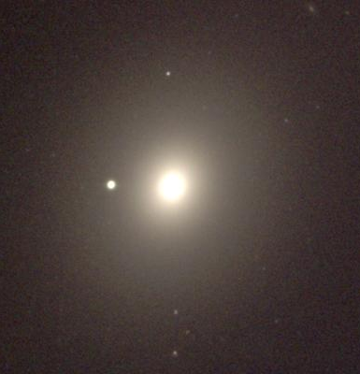  3) M49 | 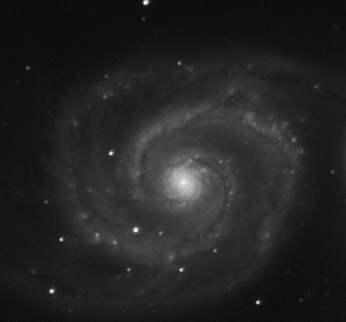  4) M51

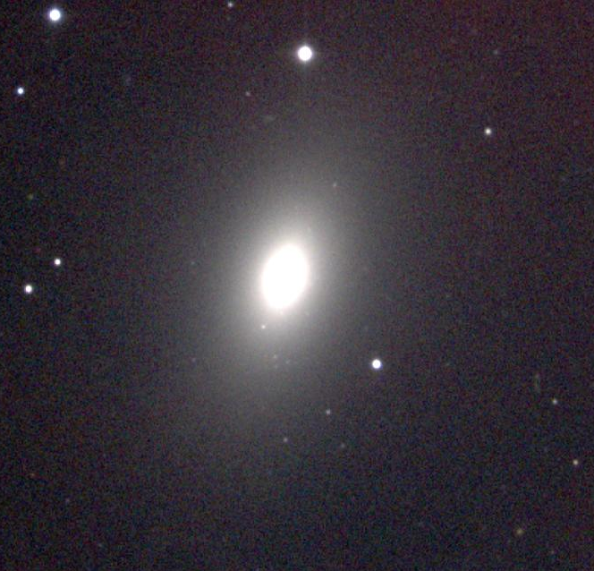  5) M59 | 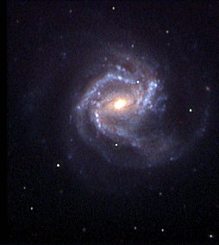  6) M61
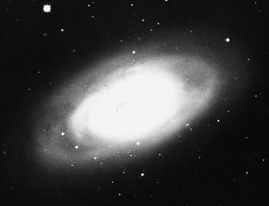  7) M64 | 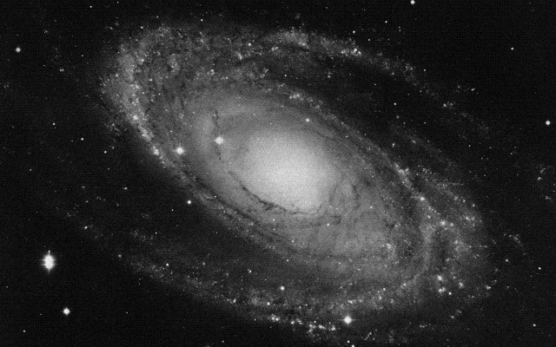  8) M81

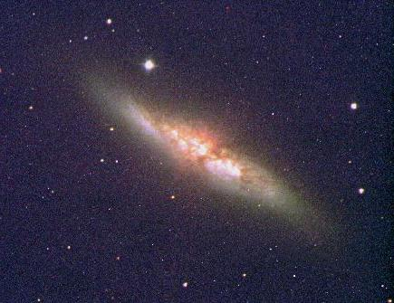  9) M82 | 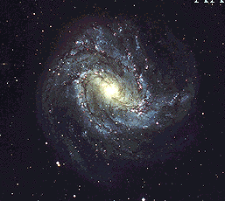  10) M83
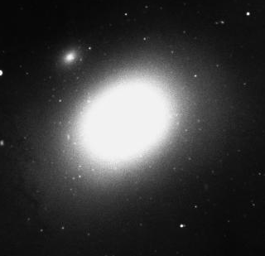  11) M84 | 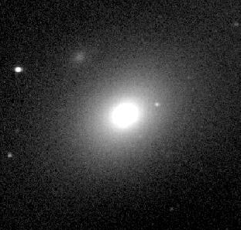  12) M86

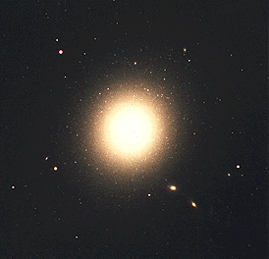  13) M87 | 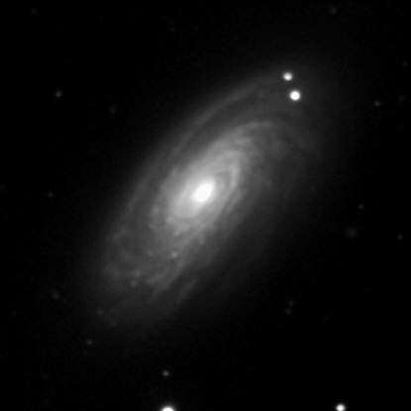  14) M88
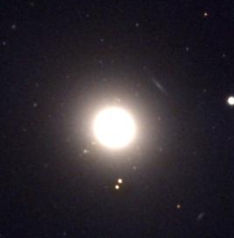  15) M89 | 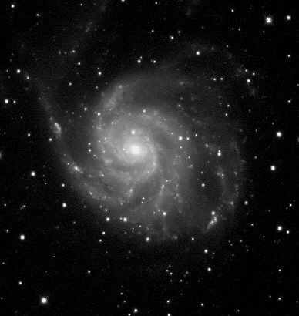  16) M101

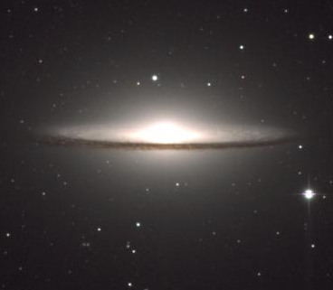  17) M104 | 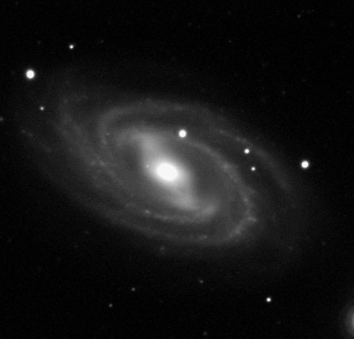  18) M109
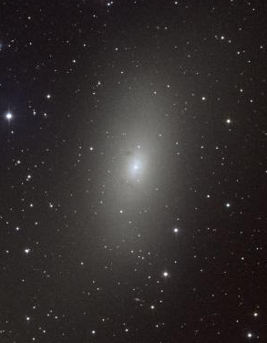  19) M110 | 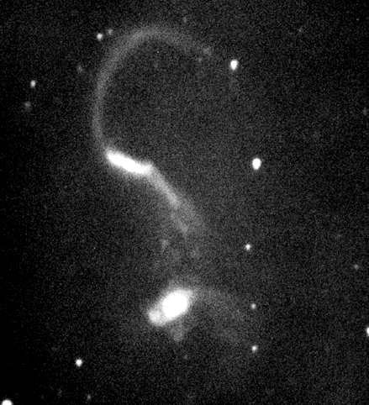  20) Arp 252

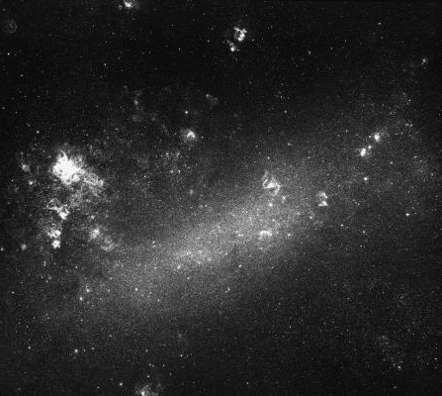  21) LMC | 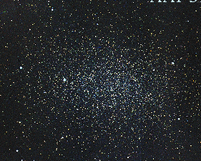  22) Leo I
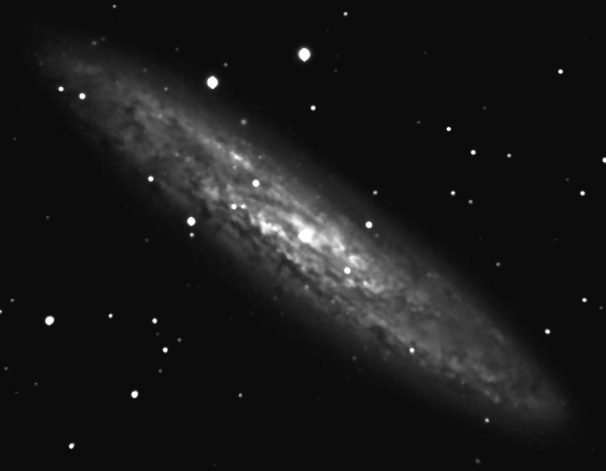  23) NGC 253 | 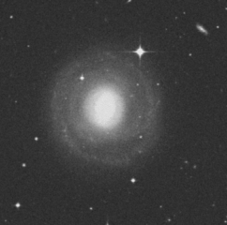  24) NGC 1302

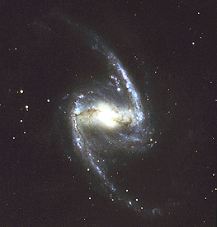  25) NGC 1365 | 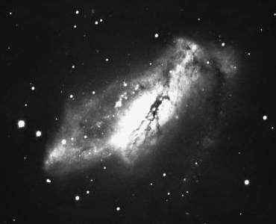  26) NGC 2146
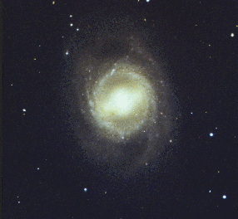  27) NGC 3351 | 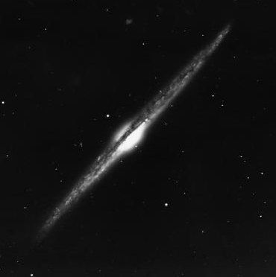  28) NGC 4565

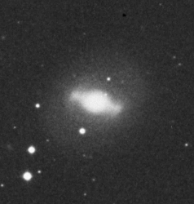  29) NGC 4596 | 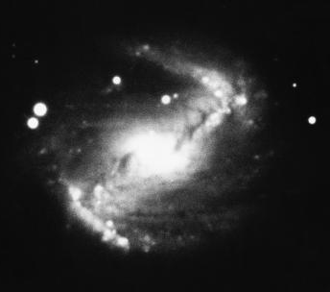  30) NGC 5383
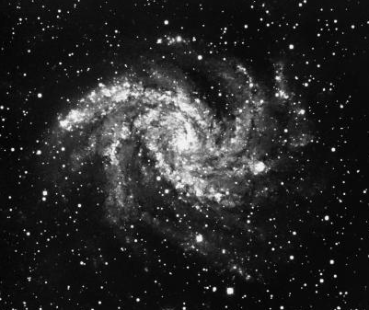  31) NGC 6946 | 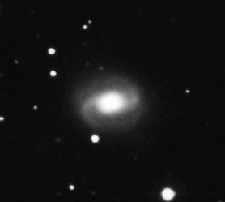  32) NGC 7743

On this page, describe your classification system. Be sure to give the name of each class and describe the properties each class does or does not posses. Be specific. If I give you another galaxy, you should be able to place it into a category based on these descriptions.

In the table below write the class each galaxy belongs to.

Galaxy | Class | Galaxy | Class
1) M31 |  | 17) M104
2) M32 |  | 18) M109
3) M49 |  | 19) M110
4) M51 |  | 20) Arp 252
5) M59 |  | 21) LMC
6) M61 |  | 22) Leo I
7) M64 |  | 23) NGC 253
8) M81 |  | 24) NGC 1302
9) M82 |  | 25) NGC 1365
10) M83 |  | 26) NGC 2146
11) M84 |  | 27) NGC 3351
12) M86 |  | 28) NGC 4565
13) M87 |  | 29) NGC 4596
14) M88 |  | 30) NGC 5283
15) M89 |  | 31) NGC 6946
16) M101 |  | 32) NGC 7743

When you reach this point, ask the instructor for Part 2 of the lab.
PART 2: CLASSIFY GALAXIES IN YOUR SCHEME

Below are images of two more galaxies. Next to each, write the name of the class in your scheme to which you would assign each galaxy.

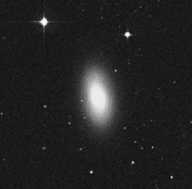
NGC 1201

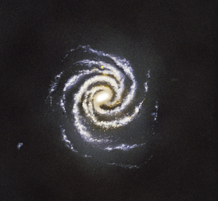
The Milky Way – Artist’s conception

When you reach this point, tell the instructor you are done and wait for Part 3.
PART 3: HUBBLE’S CLASSIFICATION SYSTEM

Astronomers have been using a classification scheme developed by Edwin Hubble in the 1920s. Read about this system in your textbook, chapter 15 pages 378-383. In the space below, write a brief description of each class of galaxy. Note: While the descriptions in the book are correct, some of the classifications given for specific galaxies are slightly off.

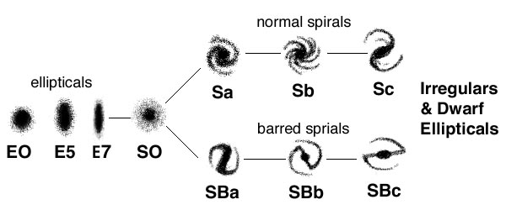

In the table below write the Hubble class each galaxy belongs to.

Galaxy | Class | Galaxy | Class
1) M31 |  | 17) M104
2) M32 |  | 18) M109
3) M49 |  | 19) M110
4) M51 |  | 20) Arp 252
5) M59 |  | 21) LMC
6) M61 |  | 22) Leo I
7) M64 |  | 23) NGC 253
8) M81 |  | 24) NGC 1302
9) M82 |  | 25) NGC 1365
10) M83 |  | 26) NGC 2146
11) M84 |  | 27) NGC 3351
12) M86 |  | 28) NGC 4565
13) M87 |  | 29) NGC 4596
14) M88 |  | 30) NGC 5283
15) M89 |  | 31) NGC 6946
16) M101 |  | 32) NGC 7743
NGC 1201 |  | Milky Way

You have finally reached the end of the lab.

