Physics 103
General Astronomy
HW #4

Recommended readings:
For unmanned space missions: http://www.jpl.nasa.gov/missions/missions_index.html
For general planetary information: http://www.nineplanets.org/

Questions:

- Briefly describe the three kinds of plate margins. Which type is located nearest to the University of Redlands? Limit your answer to less than a half page.

- Which of the terrestrial planets is most like the Earth? In what ways is it similar? In what ways is it different? Limit your answer to less than a half page.

- Pick an unmanned space mission to a terrestrial planet. Describe the science goals and findings of the mission. Limit your discussion to less than a page.

- For each of the following images: describe the feature; speculate on how it was formed; try to identify the planet and explain how you can (or cannot) tell. For each image, try to limit your answer to a few sentences.

A.
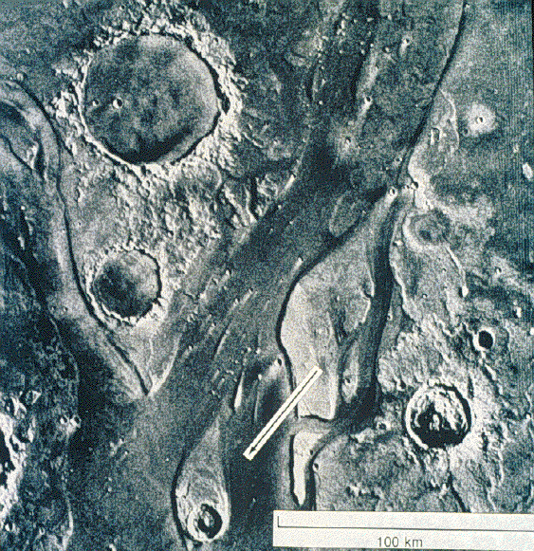

B.
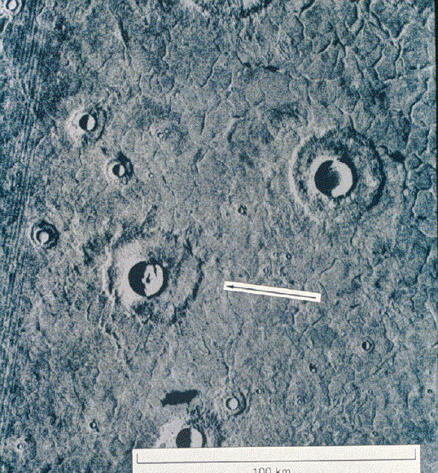

C
.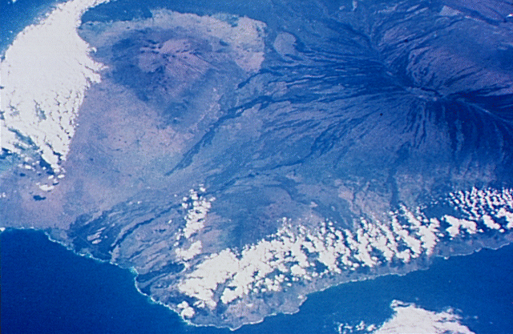

D.
