Physics 103
General Astronomy
HW #1

For this assignment ONLY, you will receive full credit simply for attempting all problems. If you need help, please come to office hours.

From the book:
Prologue problems: 1,5, 9, 10
Chapter 1 problems: 1, 3, 5, 6

Additional problems:

1.Examine this figure of a planet orbiting the Sun and fill in the blanks with the correct letter (A, B, or C):
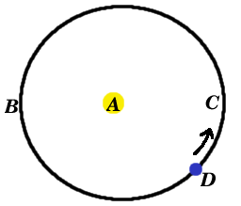
Position of Focus ____
Aphelion _____
Perihelion ____
Planet D increases speed from: to .
Planet D decreases speed from: to .
Planet has greatest speed at .
Planet has lowest speed at .

2. Calculate the approximate eccentricities for the following ellipse:

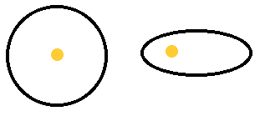
The two ellipses have the same value for a (semi-major axis). How do their values of P (Period) compare? Explain your answer.

