Read Logistic Data
Oliver d’Pug
Chinley d’Pug

Read Data
The data for the logistic model are stored in a CSV file. We can read the data using either the base or tidyverse functions.

Base
Use read.csv() to get the data. Request a listing of the first six observations as well as a list of the variables.
retention = read.csv("Data/logistic.csv")
head(retention)
STUDID GENDER RACE BDAYMO BDAYYR BEHAVE1 BEHAVE2 ATTEND LETREC1C LETREC1L
1 28 0 2 6 89 1 1 0 23 22
2 139 0 2 5 89 2 2 10 26 24
3 164 1 1 5 89 2 2 0 5 0
4 201 1 2 9 89 1 2 3 21 18
5 221 0 3 12 88 1 1 13 6 4
6 318 1 3 10 89 4 3 17 7 5
NOREC1 NOREC2 TOTCHILD BRTHORDR BILING ROUND2 RETAINED TEACHER SCHOOL
1 10 12 3 2 0 1 0 2 1
2 20 20 2 1 0 1 0 4 1
3 3 4 2 1 0 1 1 4 1
4 19 20 5 4 0 1 0 2 1
5 2 7 4 3 0 1 1 1 1
6 8 11 3 3 0 1 0 2 1
LETREC2C LETREC2L AGE1290 RACE1 RACE2 RACE3 RACEO SCHOOL2 TEACHER1 TEACHER2
1 26 25 18 0 1 0 0 0 0 1
2 26 26 19 0 1 0 0 0 0 0
3 5 0 19 1 0 0 0 0 0 0
4 26 22 15 0 1 0 0 0 0 1
5 10 4 24 0 0 1 0 0 1 0
6 19 15 14 0 0 1 0 0 0 1
TEACHER3 TEACHER4 TOTORDR LR1CRND2 ORDRRND2 TOTCRND2 R2ORDR R2TOT
1 0 0 6 23 2 3 2 3
2 0 1 2 26 1 2 1 2
3 0 1 2 5 1 2 0 0
4 0 0 20 21 4 5 4 5
5 0 0 12 6 3 4 0 0
6 0 0 9 7 3 3 0 0
names(retention)
[1] "STUDID" "GENDER" "RACE" "BDAYMO" "BDAYYR" "BEHAVE1"
[7] "BEHAVE2" "ATTEND" "LETREC1C" "LETREC1L" "NOREC1" "NOREC2"
[13] "TOTCHILD" "BRTHORDR" "BILING" "ROUND2" "RETAINED" "TEACHER"
[19] "SCHOOL" "LETREC2C" "LETREC2L" "AGE1290" "RACE1" "RACE2"
[25] "RACE3" "RACEO" "SCHOOL2" "TEACHER1" "TEACHER2" "TEACHER3"
[31] "TEACHER4" "TOTORDR" "LR1CRND2" "ORDRRND2" "TOTCRND2" "R2ORDR"
[37] "R2TOT"

Tidyverse
Use read_csv() to get the data. Again, we request a listing of the first six observations as well as a list of the variables.
re10tion = read_csv("Data/logistic.csv")
Rows: 111 Columns: 37
── Column specification ────────────────────────────────────────────────────────
Delimiter: ","
dbl (37): STUDID, GENDER, RACE, BDAYMO, BDAYYR, BEHAVE1, BEHAVE2, ATTEND, LE...
ℹ Use `spec()` to retrieve the full column specification for this data.
ℹ Specify the column types or set `show_col_types = FALSE` to quiet this message.
head(re10tion)
# A tibble: 6 × 37
STUDID GENDER RACE BDAYMO BDAYYR BEHAVE1 BEHAVE2 ATTEND LETREC1C LETREC1L
<dbl> <dbl> <dbl> <dbl> <dbl> <dbl> <dbl> <dbl> <dbl> <dbl>
1 28 0 2 6 89 1 1 0 23 22
2 139 0 2 5 89 2 2 10 26 24
3 164 1 1 5 89 2 2 0 5 0
4 201 1 2 9 89 1 2 3 21 18
5 221 0 3 12 88 1 1 13 6 4
6 318 1 3 10 89 4 3 17 7 5
# ℹ 27 more variables: NOREC1 <dbl>, NOREC2 <dbl>, TOTCHILD <dbl>,
# BRTHORDR <dbl>, BILING <dbl>, ROUND2 <dbl>, RETAINED <dbl>, TEACHER <dbl>,
# SCHOOL <dbl>, LETREC2C <dbl>, LETREC2L <dbl>, AGE1290 <dbl>, RACE1 <dbl>,
# RACE2 <dbl>, RACE3 <dbl>, RACEO <dbl>, SCHOOL2 <dbl>, TEACHER1 <dbl>,
# TEACHER2 <dbl>, TEACHER3 <dbl>, TEACHER4 <dbl>, TOTORDR <dbl>,
# LR1CRND2 <dbl>, ORDRRND2 <dbl>, TOTCRND2 <dbl>, R2ORDR <dbl>, R2TOT <dbl>
names(re10tion)
[1] "STUDID" "GENDER" "RACE" "BDAYMO" "BDAYYR" "BEHAVE1"
[7] "BEHAVE2" "ATTEND" "LETREC1C" "LETREC1L" "NOREC1" "NOREC2"
[13] "TOTCHILD" "BRTHORDR" "BILING" "ROUND2" "RETAINED" "TEACHER"
[19] "SCHOOL" "LETREC2C" "LETREC2L" "AGE1290" "RACE1" "RACE2"
[25] "RACE3" "RACEO" "SCHOOL2" "TEACHER1" "TEACHER2" "TEACHER3"
[31] "TEACHER4" "TOTORDR" "LR1CRND2" "ORDRRND2" "TOTCRND2" "R2ORDR"
[37] "R2TOT"

Change Data Types
Because the data were stored as CSV, the data types of the variables are not necessarily correct. We can re-type the variables before we use them so that R treats them properly.
retention = re10tion %>%
mutate(
Gender = factor(GENDER,
levels = 0:1,
labels = c("Female", "Male")
),
Behave1 = factor(BEHAVE1,
levels = 1:4,
labels = c("Good", "Satisfactory", "Unsatisfactory", "Bad"),
ordered = TRUE
),
Race = factor(RACE,
levels = 1:7,
labels = c("Black", "White", "Hispanic", "Pacific Islander",
"Asian", "Filipino", "Other")
),
Bilingual = factor(BILING,
levels = 0:1,
labels = c("No", "Yes")
),
Teacher = factor(TEACHER),
School = factor(SCHOOL),
Round_2 = factor(ROUND2,
levels = 0:1,
labels = c("No", "Yes")
),
Retained = factor(RETAINED,
levels = 0:1,
labels = c("No", "Yes")
)
) %>%
rename(
Student_ID = STUDID,
Age_12_90 = AGE1290,
BDay_Mo = BDAYMO,
BDay_Yr = BDAYYR,
Let_Rec_1_Cap = LETREC1C,
Let_Rec_1_Lower = LETREC1L,
Tot_Children = TOTCHILD,
Birth_Order = BRTHORDR
) %>%
select(
Retained,
Student_ID, Age_12_90, BDay_Mo, BDay_Yr,
Let_Rec_1_Cap, Let_Rec_1_Lower, Tot_Children,
Birth_Order, Gender, Behave1, Race,
Bilingual, Teacher, School, Round_2
)
names(retention)
[1] "Retained" "Student_ID" "Age_12_90" "BDay_Mo"
[5] "BDay_Yr" "Let_Rec_1_Cap" "Let_Rec_1_Lower" "Tot_Children"
[9] "Birth_Order" "Gender" "Behave1" "Race"
[13] "Bilingual" "Teacher" "School" "Round_2"

Check the Data
We perform a quick plot or two and a simple logistic model to see if things look okay.
bwplot(Retained ~ Let_Rec_1_Cap,
data=retention
)
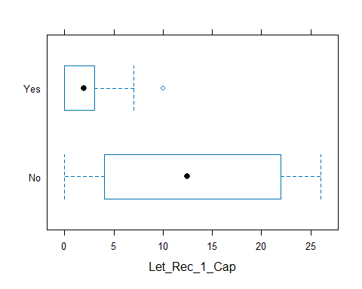
xyplot(Retained ~ Let_Rec_1_Cap,
data=retention,
type=c("p","r")
)
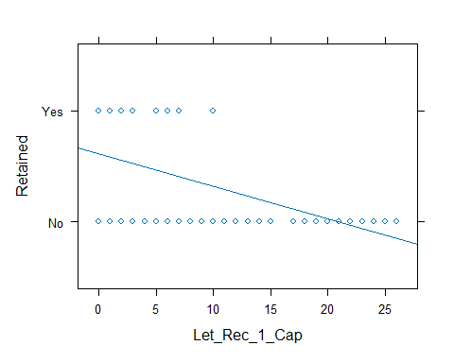
xyplot(Let_Rec_1_Lower ~ Let_Rec_1_Cap,
data=retention,
type=c("p"),
col = retention$Retained
)
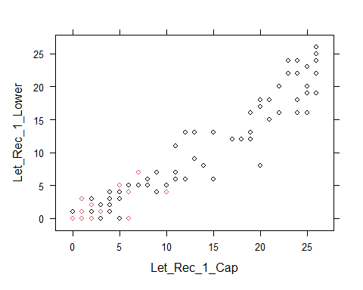
retained.glm.cap.lower = glm(Retained ~ Let_Rec_1_Cap*Let_Rec_1_Lower,
family = binomial,
data = retention)
summary(retained.glm.cap.lower)
Call:
glm(formula = Retained ~ Let_Rec_1_Cap * Let_Rec_1_Lower, family = binomial,
data = retention)
Coefficients:
Estimate Std. Error z value Pr(>|z|)
(Intercept) 1.040240 0.465417 2.235 0.0254 *
Let_Rec_1_Cap -0.177700 0.178615 -0.995 0.3198
Let_Rec_1_Lower -0.199245 0.276776 -0.720 0.4716
Let_Rec_1_Cap:Let_Rec_1_Lower -0.007099 0.033285 -0.213 0.8311
---
Signif. codes: 0 '***' 0.001 '**' 0.01 '*' 0.05 '.' 0.1 ' ' 1
(Dispersion parameter for binomial family taken to be 1)
Null deviance: 141.306 on 110 degrees of freedom
Residual deviance: 86.531 on 107 degrees of freedom
AIC: 94.531
Number of Fisher Scoring iterations: 10
anova(retained.glm.cap.lower)
Analysis of Deviance Table
Model: binomial, link: logit
Response: Retained
Terms added sequentially (first to last)
Df Deviance Resid. Df Resid. Dev Pr(>Chi)
NULL 110 141.306
Let_Rec_1_Cap 1 53.365 109 87.941 2.769e-13 ***
Let_Rec_1_Lower 1 1.356 108 86.585 0.2442
Let_Rec_1_Cap:Let_Rec_1_Lower 1 0.054 107 86.531 0.8164
---
Signif. codes: 0 '***' 0.001 '**' 0.01 '*' 0.05 '.' 0.1 ' ' 1
retained.glm.cap.lower = glm(Retained ~ Let_Rec_1_Cap + Let_Rec_1_Lower,
family = binomial,
data = retention)
summary(retained.glm.cap.lower)
Call:
glm(formula = Retained ~ Let_Rec_1_Cap + Let_Rec_1_Lower, family = binomial,
data = retention)
Coefficients:
Estimate Std. Error z value Pr(>|z|)
(Intercept) 1.1024 0.3778 2.918 0.00352 **
Let_Rec_1_Cap -0.1982 0.1513 -1.310 0.19036
Let_Rec_1_Lower -0.2392 0.2099 -1.140 0.25444
---
Signif. codes: 0 '***' 0.001 '**' 0.01 '*' 0.05 '.' 0.1 ' ' 1
(Dispersion parameter for binomial family taken to be 1)
Null deviance: 141.306 on 110 degrees of freedom
Residual deviance: 86.585 on 108 degrees of freedom
AIC: 92.585
Number of Fisher Scoring iterations: 7
anova(retained.glm.cap.lower)
Analysis of Deviance Table
Model: binomial, link: logit
Response: Retained
Terms added sequentially (first to last)
Df Deviance Resid. Df Resid. Dev Pr(>Chi)
NULL 110 141.306
Let_Rec_1_Cap 1 53.365 109 87.941 2.769e-13 ***
Let_Rec_1_Lower 1 1.356 108 86.585 0.2442
---
Signif. codes: 0 '***' 0.001 '**' 0.01 '*' 0.05 '.' 0.1 ' ' 1
retained.glm.cap = glm(Retained ~ Let_Rec_1_Cap,
family = binomial,
data = retention)
summary(retained.glm.cap)
Call:
glm(formula = Retained ~ Let_Rec_1_Cap, family = binomial, data = retention)
Coefficients:
Estimate Std. Error z value Pr(>|z|)
(Intercept) 1.11767 0.37343 2.993 0.00276 **
Let_Rec_1_Cap -0.34541 0.08862 -3.898 9.71e-05 ***
---
Signif. codes: 0 '***' 0.001 '**' 0.01 '*' 0.05 '.' 0.1 ' ' 1
(Dispersion parameter for binomial family taken to be 1)
Null deviance: 141.306 on 110 degrees of freedom
Residual deviance: 87.941 on 109 degrees of freedom
AIC: 91.941
Number of Fisher Scoring iterations: 7
anova(retained.glm.cap)
Analysis of Deviance Table
Model: binomial, link: logit
Response: Retained
Terms added sequentially (first to last)
Df Deviance Resid. Df Resid. Dev Pr(>Chi)
NULL 110 141.306
Let_Rec_1_Cap 1 53.365 109 87.941 2.769e-13 ***
---
Signif. codes: 0 '***' 0.001 '**' 0.01 '*' 0.05 '.' 0.1 ' ' 1

