Time Plots

JuJu

## Get Data

Data may be imported from a local file or downloaded from the web. For this example we will use an R internal example time series variable, ***sunspot.month***. The ***save***d time series may also be ***load***ed from the web.

# The internal data set may be called directly  
 sunspot.month[1:15]

## [1] 58.0 62.6 70.0 55.7 85.0 83.5 94.8 66.3 75.9 75.5 158.6 85.2  
## [13] 73.3 75.9 89.2

# It is not "local"  
 ls()

## character(0)

# We load the saved sunspot.month from facweb1.  
 # This fails because redlands.edu won't serve Rdata files  
 #load(url("http://facweb1.redlands.edu/fac/jim_bentley/downloads/R/sunspotmonth.Rdata"))  
 # It is now "local"  
 sunspot.month = sunspot.month[1:15]  
 ls()

## [1] "sunspot.month"

sunspot.month[1:15]

## [1] 58.0 62.6 70.0 55.7 85.0 83.5 94.8 66.3 75.9 75.5 158.6 85.2  
## [13] 73.3 75.9 89.2

# Remove the local copy  
 rm(sunspot.month)  
 # Check to see if the "global" copy is still there  
 sunspot.month[1:15]

## [1] 58.0 62.6 70.0 55.7 85.0 83.5 94.8 66.3 75.9 75.5 158.6 85.2  
## [13] 73.3 75.9 89.2

## Time Plots

For now, We will focus on the first 15 months in the series.

# Plot using points  
 plot(sunspot.month[1:15], ylab="Avg. Daily Sunspots per Mo.")

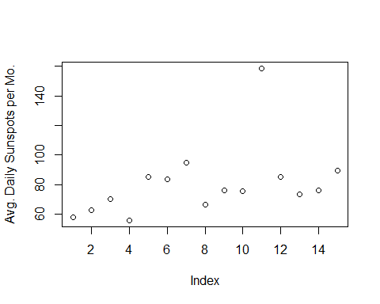

# Plot using lines  
 plot(sunspot.month[1:15], type="l", ylab="Avg. Daily Sunspots per Mo.")

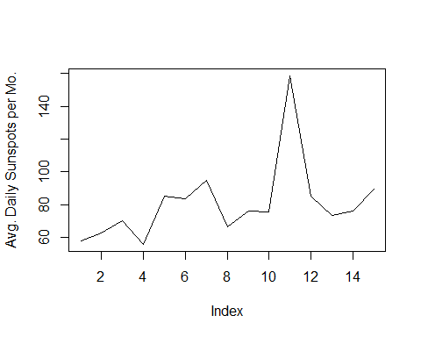

# Plot using both points and lines  
 plot(sunspot.month[1:15], type="b", ylab="Avg. Daily Sunspots per Mo.")

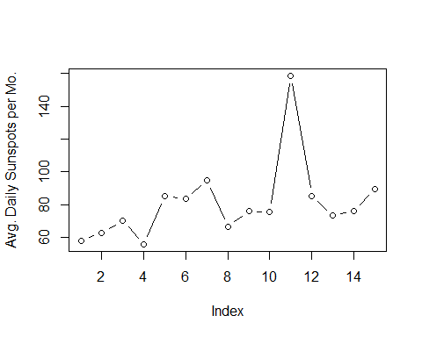

It appears that the average number of daily sunspots per month is increasing over months. A line that describes this relationship is ***adspm*** = 62.959 + 2.209 (***Index***). This line can be added to the plot using the ***abline*** function.

# Base R  
 plot(sunspot.month[1:15], ylab="Avg. Daily Sunspots per Mo.")  
 abline(a=62.959, b=2.209, col="red", lty=2)  
 #  
 # Now use lattice to create a similar plot  
 p_load(lattice)

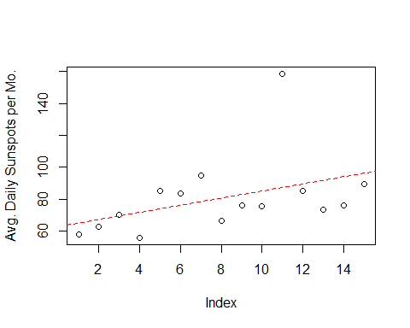

month=1:15  
 xyplot(sunspot.month[1:15]~month,   
 panel=function(x, y, ...){  
 panel.xyplot(x, y, ...)  
 panel.abline(a=62.959, b=2.209, col="red", lty=2)  
 }, ylab="Avg. Daily Sunspots per Mo."  
 )

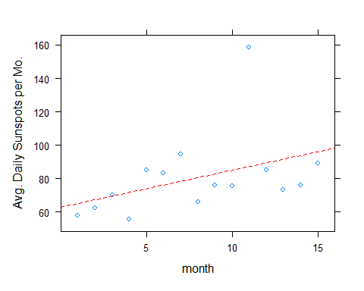

According to this plot a good guess for the adspm 10 years from the start would be about 60 + 2(120) = 300. And, 100 years from the start we should see 60 + 2(1200) = 2460. A plot can confirm this.

# Base R  
 plot(sunspot.month, ylab="Avg. Daily Sunspots per Mo.")

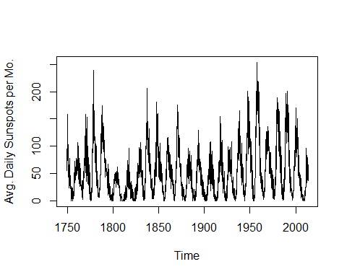

# Use lattice  
 xyplot(sunspot.month, ylab="Avg. Daily Sunspots per Mo.")

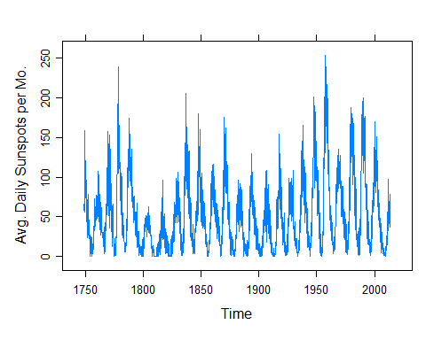

Actually, the plot appears to refute the increasing nature of the number of sunspots. Instead we see that the number of sunspots seems to cycle every 10 years or so. Be careful extrapolating from the short term to the long term.