GLM in R

Oliver and JuJu

## Data Entry

The following code creates a sample data frame that we will use in our examples.

# Import the height and weight data  
 htwt = read.csv("http://facweb1.redlands.edu/fac/jim_bentley/downloads/math111/htwt.csv")  
 # The Group variable is actually categorical and not numeric  
 htwt$Group = factor(htwt$Group,levels=c(1,2),labels=c("Male","Female"))  
 head(htwt)

## Height Weight Group  
## 1 64 159 Male  
## 2 63 155 Female  
## 3 67 157 Female  
## 4 60 125 Male  
## 5 52 103 Female  
## 6 58 122 Female

## Testing The Population Mean

### The One Sample Test

A simple test for the population mean of the **Weight** variable in the **htwt** data can be obtained via the **t.test** function. To compute the one sample t-test of H0: mu=145 we enter:

t.test(htwt$Weight, mu=145, alternative='two.sided', conf.level=.95)

##   
## One Sample t-test  
##   
## data: htwt$Weight  
## t = -0.56003, df = 19, p-value = 0.582  
## alternative hypothesis: true mean is not equal to 145  
## 95 percent confidence interval:  
## 119.4182 159.7818  
## sample estimates:  
## mean of x   
## 139.6

An equivalent test of H0: mu=145 may be carried out using a linear model via the **lm** function.

summary(lm((Weight-145)~1, data=htwt))

##   
## Call:  
## lm(formula = (Weight - 145) ~ 1, data = htwt)  
##   
## Residuals:  
## Min 1Q Median 3Q Max   
## -57.60 -31.35 -16.10 27.15 88.40   
##   
## Coefficients:  
## Estimate Std. Error t value Pr(>|t|)  
## (Intercept) -5.400 9.642 -0.56 0.582  
##   
## Residual standard error: 43.12 on 19 degrees of freedom

Notice that adding the coefficient from the model to the hypothesized mean gives the sample mean. That is 145+(-5.4)=139.6. Note, too that the p-values computed by **t.test** and **lm** are the same (p=0.582).

### The Two Sample Test

A simple test to compare the male and female population means of the **Weight** variable in the **htwt** data can also be obtained via the **t.test** function. To compute the two sample t-test of H0: mu.m = mu.f we enter:

t.test(Weight~Group, alternative='two.sided', conf.level=.95,  
 var.equal=TRUE, data=htwt)

##   
## Two Sample t-test  
##   
## data: Weight by Group  
## t = 1.4903, df = 18, p-value = 0.1534  
## alternative hypothesis: true difference in means between group Male and group Female is not equal to 0  
## 95 percent confidence interval:  
## -11.4713 67.4713  
## sample estimates:  
## mean in group Male mean in group Female   
## 155 127

An equivalent test of H0: beta1 = 0 = mu.m-mu.f may be carried out using a linear model via the **lm** function.

htwt.lm.Group = lm(Weight~Group, data=htwt)  
 summary(htwt.lm.Group)

##   
## Call:  
## lm(formula = Weight ~ Group, data = htwt)  
##   
## Residuals:  
## Min 1Q Median 3Q Max   
## -68.00 -31.50 -6.50 31.25 73.00   
##   
## Coefficients:  
## Estimate Std. Error t value Pr(>|t|)   
## (Intercept) 155.00 13.93 11.12 1.69e-09 ***  
## GroupFemale -28.00 18.79 -1.49 0.153   
## ---  
## Signif. codes: 0 '***' 0.001 '**' 0.01 '*' 0.05 '.' 0.1 ' ' 1  
##   
## Residual standard error: 41.8 on 18 degrees of freedom  
## Multiple R-squared: 0.1098, Adjusted R-squared: 0.06039   
## F-statistic: 2.221 on 1 and 18 DF, p-value: 0.1534

plot(htwt$Group,htwt$Weight)  
 points(c(1,2),by(htwt[,2],htwt[,3],mean),type="b")

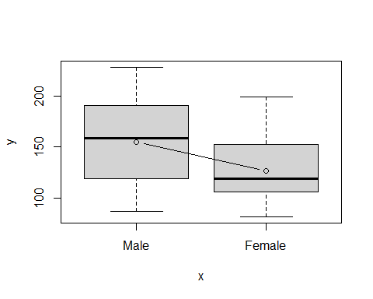

par(mfrow=c(2,2))  
 plot(htwt.lm.Group)

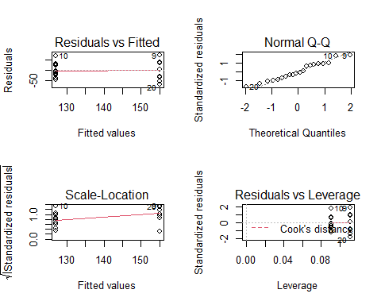

par(mfrow=c(1,1))

Notice that intercept term (155) is the sample mean for the males. The sample mean for the females is the model evaluated for a female (155+(-28)=127). As in the one sample problem the p-values computed by **t.test** and **lm** are the same (p=0.153).

### Correcting for Height

It is fairly clear from graphing **Weight** as a function of **Height** that when modeling a person’s weight we should correct for height. While this cannot be accomplished using a t-test, a linear model makes the correction fairly easy.

To test for H0: beta.1 = 0 when controlling for **Height** using the model Weight = beta.0 + beta.1 Female + beta.2 Height + epsilon we compute

summary(lm(Weight~1+Group+Height, data=htwt))

##   
## Call:  
## lm(formula = Weight ~ 1 + Group + Height, data = htwt)  
##   
## Residuals:  
## Min 1Q Median 3Q Max   
## -9.539 -6.022 -1.253 4.032 14.720   
##   
## Coefficients:  
## Estimate Std. Error t value Pr(>|t|)   
## (Intercept) -170.6997 13.8866 -12.292 6.96e-10 ***  
## GroupFemale -1.5796 3.4779 -0.454 0.655   
## Height 5.0108 0.2103 23.826 1.68e-14 ***  
## ---  
## Signif. codes: 0 '***' 0.001 '**' 0.01 '*' 0.05 '.' 0.1 ' ' 1  
##   
## Residual standard error: 7.334 on 17 degrees of freedom  
## Multiple R-squared: 0.9741, Adjusted R-squared: 0.9711   
## F-statistic: 319.9 on 2 and 17 DF, p-value: 3.239e-14

plot(htwt$Height,htwt$Weight,pch=as.numeric(htwt$Group),xlab="Height",ylab="Weight")  
 htwt.lm.HG=lm(Weight~Height+Group,data=htwt)  
 abline(coef(htwt.lm.HG)%*%cbind(c(1,0,0),c(0,1,0)),lty=1)  
 abline(coef(htwt.lm.HG)%*%cbind(c(1,0,1),c(0,1,0)),lty=2)  
 legend(55,200,legend=c("Male","Female"),pch=c(1,2),lty=c(1,2))

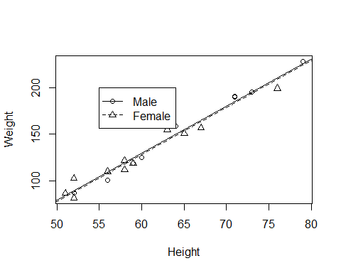

Notice that as before there does note appear to be a difference between females and males (p=0.655). However, it is clear that **Height** is predictive of **Weight** (p<0.001).

### Interaction Terms

At this point we may be convinced that no differences exist in the weights of our two groups. Clearly the means for this sample are not significantly different. A little more insight may be gained by including an interaction term.

We now fit the model

Weight = beta.0 + beta.1 Female + beta.2 Height + beta.3 Female x Height + epsilon

htwt.lm.GbyH = lm(Weight~1+Group*Height, data=htwt)  
 summary(htwt.lm.GbyH)

##   
## Call:  
## lm(formula = Weight ~ 1 + Group * Height, data = htwt)  
##   
## Residuals:  
## Min 1Q Median 3Q Max   
## -9.968 -3.413 -1.104 2.697 13.163   
##   
## Coefficients:  
## Estimate Std. Error t value Pr(>|t|)   
## (Intercept) -198.2609 16.6933 -11.877 2.39e-09 ***  
## GroupFemale 54.4858 23.2997 2.338 0.0327 *   
## Height 5.4348 0.2547 21.340 3.51e-13 ***  
## GroupFemale:Height -0.9013 0.3713 -2.427 0.0274 *   
## ---  
## Signif. codes: 0 '***' 0.001 '**' 0.01 '*' 0.05 '.' 0.1 ' ' 1  
##   
## Residual standard error: 6.463 on 16 degrees of freedom  
## Multiple R-squared: 0.9811, Adjusted R-squared: 0.9775   
## F-statistic: 276.6 on 3 and 16 DF, p-value: 5.425e-14

plot(htwt.lm.GbyH)

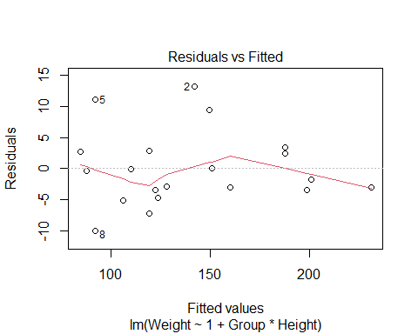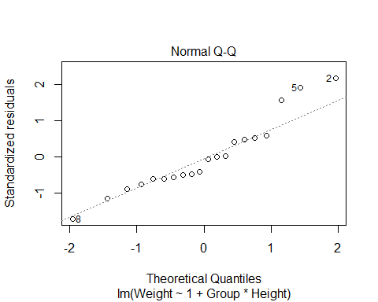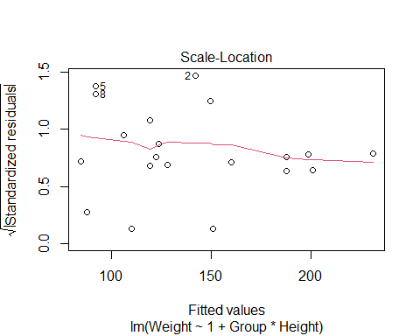

# Using lattice  
 p_load(lattice)

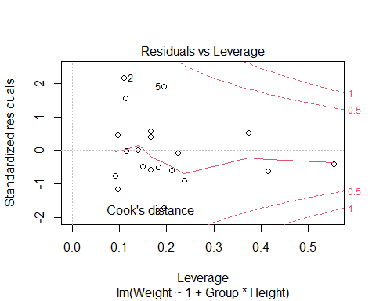

xyplot(Weight~Height, group=Group,data=htwt,type=c("p","r"),   
 pch=c(1,3),   
 col=c(5,6),   
 key=list(text=list(lab=c("Male","Female")),   
 lines=list(pch=c(1,3),lty=c(1,2),col=c(5,6),type="b")))

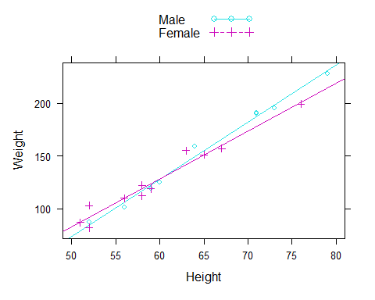

# Using ggplot  
 p_load(ggplot2)  
 ggplot(htwt, aes(x=Height, y=Weight, color=Group, shape=Group))+geom_point()+geom_smooth(method=lm, se=FALSE, fullrange=FALSE)

## `geom_smooth()` using formula 'y ~ x'

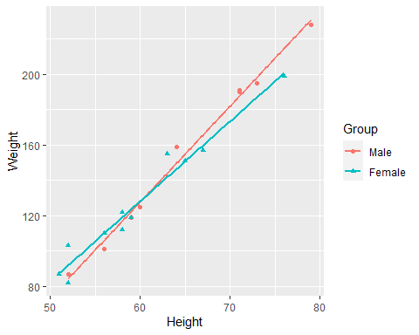

It is now clear that not only is height predictive of weight (p<0.0001), more importantly, females and males put weight on differently. Since the interaction term is significant (p=0.0274) this indicates that their slopes are different with the women putting on about one pound less per inch than the men.

Diagnostic plots can be generated by using the **plot** function on the **lm** object, **htwt.lm.GbyH**. The figure shows the four diagnostic plots that are the default. An analysis of variance table may also be generated.

# Set up the page to take all four images  
 par(mfrow=c(2,2))  
 plot(htwt.lm.GbyH)

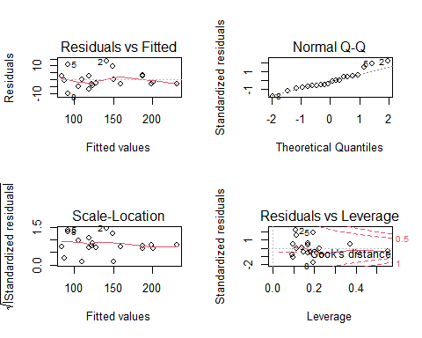

par(mfrow=c(1,1))  
 anova(htwt.lm.GbyH)

## Analysis of Variance Table  
##   
## Response: Weight  
## Df Sum Sq Mean Sq F value Pr(>F)   
## Group 1 3880.8 3880.8 92.9116 4.570e-08 ***  
## Height 1 30535.6 30535.6 731.0636 8.778e-15 ***  
## Group:Height 1 246.1 246.1 5.8921 0.02738 *   
## Residuals 16 668.3 41.8   
## ---  
## Signif. codes: 0 '***' 0.001 '**' 0.01 '*' 0.05 '.' 0.1 ' ' 1

The question of mean differences is thus shown to be the wrong question. The investigator should have been looking to see if men and women put on an equivalent number of pounds for each inch difference in height. This is something that is not apparent when looking at t-tests.